**CHAROTAR UNIVERSITY OF SCIENCE & TECHNOLOGY**

FACULTY OF TECHNOLOGY AND ENGINEERING

**Devang Patel Institute of Advance Technology & Research**

Department of Computer Engineering

**Subject Name**: Database Management System **Semester**: IV

**Subject Code**: CE246 **Academic year**: 2019-20

|  |  |  |  |  |
| --- | --- | --- | --- | --- |
| **Sr.**  **No.** | **Aim Of The Practical** | **Date** | **Page No.** | **Remark** |
| **1.** | |  | | --- | | **Introduction to Oracle Architecture.** | | 4/12/2019 | 11-13 |  |
| **2.** | **To study DDL-create and DML-insert commands**.   1. Create tables according to the following definition.    * CREATE TABLE DEPOSIT (ACTNO VARCHAR2(5), CNAME VARCHAR2(18), BNAME VARCHAR2(18), AMOUNT NUMBER (8,2), ADATE DATE);    * CREATE TABLE BRANCH (BNAME VARCHAR2(18), CITY VARCHAR2(18));    * CREATE TABLE CUSTOMERS (CNAME VARCHAR2(19), CITY VARCHAR2(18));    * CREATE TABLE BORROW (LOANNO VARCHAR2(5), CNAME VARCHAR2(18), BNAME VARCHAR2(18), AMOUNT NUMBER (8,2)); 2. Insert the data as shown below.   **DEPOSIT**   |  |  |  |  |  | | --- | --- | --- | --- | --- | | **ACT NO** | **CNAME** | **BNAME** | **AMOUNT** | **ADATE** | | 100 | ANIL | VRCE | 1000.00 | 1-MAR-95 | | 101 | SUNIL | AJNI | 5000.00 | 4-JAN-96 | | 102 | MEHUL | KAROLBGH | 3500.00 | 17-NOV-95 | | 104 | MADHURI | CHANDI | 1200.00 | 17-DEC-95 | | 105 | PRAMOD | M.G.ROAD | 3000.00 | 27-MAR-96 | | 106 | SANDIP | ANDHERI | 2000.00 | 31-MAR-96 | | 107 | SHIVANI | VIRAR | 1000.00 | 5-SEP-95 | | 108 | KRANTI | NEHRU PLACE | 5000.00 | 2-JULY-95 | | 109 | MINU | POWAI | 7000.00 | 10-AUG-95 |   **BRANCH**  **CUSTOMERS**   |  |  | | --- | --- | | **ACT NO** | **CNAME** | | ANIL | CALCUTTA | | SUNIL | DELHI | | MEHUL | BARODA | | MANDAR | PATNA | | MADHURI | NAGPUR | | PRAMOD | NAGPUR | | SANDIP | SURAT | | SHIVANI | BOMBAY | | KRANTI | BOMBAY | | NAREN | BOMBAY |  |  |  | | --- | --- | | **ACT NO** | **CNAME** | | VRCE | NAGPUR | | AJNI | NAGPUR | | KAROLBAGH | DELHI | | CHANDI | DELHI | | DHARAMPETH | NAGPUR | | M.G.ROAD | BANGLORE | | ANDHERI | BOMBAY | | VIRAR | BOMBAY | | NEHRU PLACE | DELHI | | POWAI | BOMBAY |   **BORROW**   |  |  |  |  | | --- | --- | --- | --- | | **ACT NO** | **CNAME** | **BNAME** | **AMOUNT** | | 201 | ANIL | VRCE | 1000.00 | | 206 | MEHUL | AJNI | 5000.00 | | 311 | SUNIL | DHARAMPETH | 3000.00 | | 321 | MADHURI | ANDHERI | 2000.00 | | 375 | PRMOD | VIHAR | 8000.00 | | 481 | KRANTI | NEHUR PLACE | 3000.00 |   **From the above given tables perform the following queries**:  (1) Describe deposit, branch.  (2) Describe borrow, customers.  (3) List all data from table DEPOSIT.  (4) List all data from table BORROW.  (5) List all data from table CUSTOMERS.  (6) List all data from table BRANCH.  (7) Give account no and amount of depositors.  (8) Give name of depositors having amount greater than 4000.  (9) Give name of customers who opened account after date '1-12-96'.  (10) Give name of city where branch karolbagh is located.  (11) Give account no and amount of customer having account opened between date 1-12-96 and 1-6-96.  (12) Give names of depositors having account at VRCE. | 5/12/2019 | 14-22 |  |
| **3.** | **Create the below given table and insert the data accordingly.**  Create Table **Job** (job_id, job_title, min_sal, max_sal)   |  |  | | --- | --- | | **COLUMN NAME** | **DATA TYPE** | | JOB_ID | VARCHAR2(15) | | JOB_TITLE | VARCHAR2(30) | | MIN_SAL | NUMBER(7,2) | | MAX_SL | NUMBER(7,20) |   Create table **Employee** (emp_no, emp_name, emp_sal, emp_comm, dept_no)   |  |  | | --- | --- | | **COLUMN NAME** | **DATA TYPE** | | EMP_NO | NUMBER(3) | | EMP_NAME | VARCHAR2(30) | | EMP_SAL | NUMBER(8,2) | | EMP_COMM | NUMBER(6,1) | | DEPT_NO | NUMBER(3) |   Create table **Deposit**(a_no,cname,bname,amount,a_date).   |  |  | | --- | --- | | **COLUMN NAME** | **DATA TYPE** | | A_NO | VARCHAR2(5) | | CNAME | VARCHAR2(15) | | BNAME | VHARCHAR2(10) | | AMOUNT | NUMBER(7,2) | | A_DATE | DATE |   Create table **Borrow** (loanno, cname, bname, amount).   |  |  | | --- | --- | | **COLUMN NAME** | **DATA TYPE** | | LOANNO | VARCHAR2(5) | | CNAME | VARCHAR2(10) | | BNAME | VARCHAR2(15) | | AMOUNT | NUMBER(7,2) |   Insert following values in the table **Employee**.   |  |  |  |  |  | | --- | --- | --- | --- | --- | | **EMP_NO** | **EMP_NAME** | **EMP_SAL** | **EMP_COMM** | **DEPT_NO** | | 101 | SMITH | 800 |  | 20 | | 102 | SNEHAL | 1600 | 300 | 25 | | 103 | ADAMA | 1100 | 0 | 20 | | 104 | AMAN | 3000 |  | 15 | | 105 | ANITA | 5000 | 50000 | 10 | | 106 | SNEHA | 2450 | 24500 | 10 | | 107 | ANAMIKA | 2975 |  | 30 |   Insert following values in the table **Job.**   |  |  |  |  | | --- | --- | --- | --- | | **JOB_ID** | **JOB_NAME** | **MIN_SAL** | **MAX_SAL** | | IT_PROG | PROGRAMMER | 4000 | 10000 | | MK_MGR | MARKETING MANAGER | 9000 | 15000 | | FI_MGR | FINANCE MANAGER | 8200 | 12000 | | FI_ACC | ACCOUNT | 4200 | 9000 | | LEC | LECTURER | 6000 | 17000 | | COMP_OP | COMPUTER OPERATOR | 1500 | 3000 |   Insert following values in the table **Deposit**.   |  |  |  |  |  | | --- | --- | --- | --- | --- | | **A_NO** | **CNAME** | **BNAME** | **AMOUNT** | **DATE** | | 101 | ANIL | ANDHERI | 7000 | 01-JAN-06 | | 102 | SUNIL | VIRAR | 5000 | 15-JUL-06 | | 103 | JAY | VILLEPARLE | 6500 | 12-MAR-06 | | 104 | VIJAY | ANDHERI | 8000 | 17-SEP-06 | | 105 | KEYUR | DADAR | 7500 | 19-NOV-06 | | 106 | MAYUR | BORIVALI | 5500 | 21-DEC-06 |   **Perform following queries**  (1) Retrieve all data from **employee, jobs and deposit.**  (2) Give details of account no. and deposited rupees of customers having account opened between dates **01-01-06 and 25-07-06**.  (3) Display all jobs with minimum salary is greater than 4000.  (4) Display name and salary of employee whose department no is 20. Give alias name to name of employee.  (5) Display employee no, name and department details of those employee whose department lies **in (10,20).**  (6) Display the **non-null** values of employees.  (7) Display name of customer along with its account no **(both column should be displayed as one)** whose amount is not equal to 8000 Rs.  (8) Display the content of job details with minimum salary **either 2000 or 4000**.  **To study various options of LIKE predicate**  (1)Display all employee whose name start with ‘A’ and third character is ‘‘a’.  (2) Display name, number and salary of those employees whose name is 5 characters long and first three characters are ‘Ani’.  (3) Display all information of employee whose second character of name is either ‘M’ or ‘N’.  (4) Find the list of all customer name whose branch is in ‘andheri’ or ‘dadar’ or ‘virar’.  (5) Display the job name whose first three character in job id field is ‘FI_’.  (6) Display the title/name of job who’s last three character are ‘_**MGR**’ and their maximum salary is greater than **Rs 12000**.  (7) Display the non-null values of employees and also employee name second character should be ‘n’ and string should be 5-character long.  (8) Display the null values of employee and also employee name’s third character should be ‘a’.  (9) What will be output if you are giving LIKE predicate as ‘%\_%’ ESCAPE ‘\’ | 11/12/2019 | 23-34 |  |
| **4.** | **To Perform various data manipulation commands, aggregate functions and sorting concept on all created tables.**  (1) List total deposit from deposit.  (2) List total loan from karolbagh branch  (3) Give maximum loan from branch vrce.  (4) Count total number of customers  (5) Count total number of customer’s cities.  (6) Create table supplier from employee with all the columns.  (7) Create table sup1 from employee with first two columns.  (8) Create table sup2 from employee with no data  (9) Insert the data into sup2 from employee whose second character should be ‘n’ and string should be 5 characters long in employee name field.  (10) Delete all the rows from sup1.  (11) Delete the detail of supplier whose sup_no is 103.  (12) Rename the table sup2.  (13) Destroy table sup1 with all the data.  (14) Update the value dept_no to 10 where second character of emp. Name is ‘m’.  (15) Update the value of employee name whose employee number is 103.  (16) Add one column phone to employee with size of column is 10.  (17) Modify the column emp_name to hold maximum of 30 characters.  (18) Count the total no as well as distinct rows in dept_no column with a condition of salary greater than 1000 of employee .  (19) Display the detail of all employees in ascending order, descending order of their name and no.  (20) Display the dept_no in ascending order and accordingly display emp_comm in descending order.  (21) Update the value of emp_comm to 500 where dept_no is 20.  (22) Display the emp_comm in ascending order with null value first and accordingly sort employee salary in descending order.  (23) Display the emp_comm in ascending order with null value last and accordingly sort emp_no in descending order. | 18/12/2019 | 35-49 |  |
| **5.** | **To study Single-row functions.**  (1) Write a query to display the current date. Label the column Date  (2) For each employee, display the employee number, job, salary, and salary increased by 15% and expressed as a whole number. Label the column New Salary  (3) Modify your query no (2) to add a column that subtracts the old salary from the new salary. Label the column Increase  (4) Write a query that displays the employee’s names with the first letter capitalized and all other letters lowercase, and the length of the names, for all employees whose name starts with J, A, or M. Give each column an appropriate label. Sort the results by the employees’ last names.  (5) Write a query that produces the following for each employee:  <employee last name> earns <salary> monthly  (6) Display the name, hire date, number of months employed and day of the week on which the employee has started. Order the results by the day of the week starting with Monday.  (7) Display the hiredate of emp in a format that appears as Seventh of June 1994 12:00:00 AM.  (8) Write a query to calculate the annual compensation of all employees (sal +comm.). | 1/1/2020 | 50-54 |  |
| **6.** | **Displaying data from Multiple Tables (join)**  (1) Give details of customers ANIL.  (2) Give name of customer who are borrowers and depositors and having living city agpur .  (3) Give city as their city name of customers having same living branch.  (4) Write a query to display the last name, department number, and department name for all employees.  (5) Create a unique listing of all jobs that are in department 30. Include the location of the department in the output  (6) Write a query to display the employee name, department number, and department name for all employees who work in NEW YORK.  (7) Display the employee last name and employee number along with their manager’s last name and manager number. Label the columns Employee, Emp#, Manager, and Mgr#, respectively.  (8) Create a query to display the name and hire date of any employee hired after employee SCOTT. | 8/1/2020 | 55-59 |  |
| **7.** | **To apply the concept of Aggregating Data using Group functions.**  (1) List total deposit of customer having account date after 1-jan-96.  (2) List total deposit of customers living in city Nagpur.  (3) List maximum deposit of customers living in Bombay.  (4) Display the highest, lowest, sum, and average salary of all employees. Label the columns Maximum, Minimum, Sum, and Average, respectively. Round your results to the nearest whole number.  (5) Write a query that displays the difference between the highest and lowest salaries. Label the column DIFFERENCE.  (6) Create a query that will display the total number of employees and, of that total, the number of employees hired in 1995, 1996, 1997, and 1998  (7) Find the average salaries for each department without displaying the respective department numbers.  (8) Write a query to display the total salary being paid to each job title, within each department.  (9) Find the average salaries > 2000 for each department without displaying the respective department numbers.  (10) Display the job and total salary for each job with a total salary amount exceeding 3000, in which excludes president and sorts the list by the total salary.  (11) List the branches having sum of deposit more than 5000 and located in city Bombay. | 21/1/2020 | 60-66 |  |
| **8.** | **To solve queries using the concept of sub query.**  (1) Write a query to display the last name and hire date of any employee in the same department as SCOTT. Exclude SCOTT  (2) Give name of customers who are depositors having same branch city of mr. sunil.  (3) Give deposit details and loan details of customer in same city where ramod is living.  (4) Create a query to display the employee numbers and last names of all employees who earn more than the average salary. Sort the results in ascending order of salary.  (5) Give names of depositors having same living city as mr. anil and having deposit amount greater than 2000  (6) Display the last name and salary of every employee who reports to ford.  (7) Display the department number, name, and job for every employee in the Accounting department.  (8) List the name of branch having highest number of depositors.  (9) Give the name of cities where in which the maximum numbers of branches are located.  (10) Give name of customers living in same city where maximum depositors are located. | 5/2/2020 | 62-72 |  |
| **9.** | **Manipulating Data**  (1) Give 10% interest to all depositors.  (2) Give 10% interest to all depositors having branch vrce  (3) Give 10% interest to all depositors living in ombay and having branch city ombay.  (4) Write a query which changes the department number of all employees with empno 7788’s job to employee 7844’current department number.  (5) Transfer 10 Rs from account of anil to sunil if both are having same branch.  (6) Give 100 Rs more to all depositors if they are maximum depositors in their respective branch.  (7) Delete depositors of branches having number of customers between 1 to 3.  (8) Delete deposit of vijay.  (9) Delete borrower of branches having average loan less than 1000. | 12/2/2020 | 73-78 |  |
| **10.** | **To perform basic PL/SQL blocks**  Write a PL-SQL block for checking weather a given year is a Leap year or not . | 12/2/2020 | 79 |  |
| **11.** | **To perform the concept of loop**  Find out whether given string is palindrome or not using for, While and Simple Loop. | 26/2/2020 | 80 |  |
| **12.** | **To understand the concept of “select into” and “% type” attribute**.  Create an EMPLOYEES table that is a replica of the EMP table. Add a new column, STARS, of VARCHAR2 data type and length of 50 to the EMPLOYEES table for storing asterisk (*).  Create a PL/SQL block that rewards an employee by appending an asterisk in the STARS column for every Rs1000/- of the employee’s salary. For example, if the employee has a salary amount of Rs8000/-, the string of asterisks should contain eight asterisks. If the employee has a salary amount of Rs12500/-, the string of asterisks should contain 13 asterisks.  Update the STARS column for the employee with the string of asterisks. | 4/3/2020 | 81-82 |  |
| **13.** | **To perform the concept of cursor**  (a) Display all the information of EMP table using %ROWTYPE.  (b) Create a PL/SQL block that does the following:  In a PL/SQL block, retrieve the name, salary, and MANAGER ID of the employees working in the particular department. Take Department Id from user.  If the salary of the employee is less than 1000 and if the manager ID is either 7902 or 7839, display the message <<last name>> Due for a raise. Otherwise, display the message <<last_name>> Not due for a raise. | 4/3/2020 | 83-84 |  |
| **14.** | **To perform the concept of trigger**  Write a PL/SQL block to update the salary where deptno is 10. Generate trigger that will store the original record in other table before updation take place | 11/3/2020 | 85 |  |
| **15.** | **To perform the concept of function and procedure**  Write a PL/SQL block to update the salary of employee specified by empid. If record exist, then update the salary otherwise display appropriate message. Write a function as well as procedure for updating salary. | 25/3/2020 | 86-87 |  |
| **16.** | **To perform the concept of exception handler**  Write a PL/SQL block that will accept the employee code, amount and operation. Based on specified operation amount is added or deducted from salary of said employee. Use user defined exception handler for handling the exception. | 25/3/2020 | 88 |  |
| **17.** | **To perform the concept of package**  Create and invoke a package that contains private and public constructs. | 31/3/2020 | 89-91 |  |

**PRACTICAL – 1**

**Aim: introduction to oracle architecture.**

**Hardware Required:** Computer/Laptop

**Software Required:** Oracle

**Knowledge Required:** Oracle Architecture.

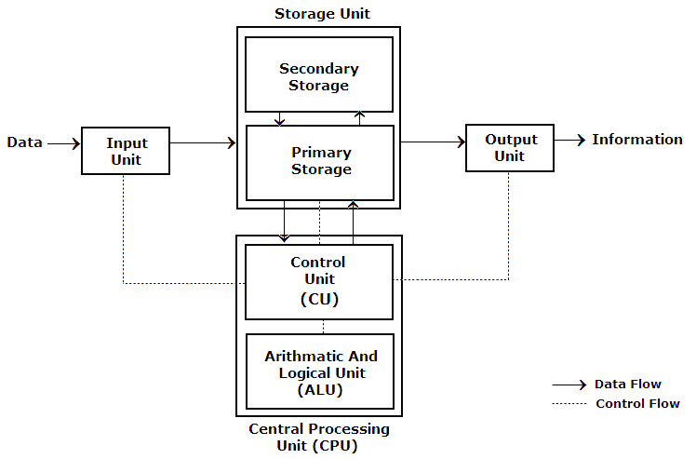**Answer:**

**Computer Architecture:** Computer architecture is a set of rules and methods that describe the functionality, organization, and implementation of computer system Some definitions of architecture define it as describing the capabilities and programming model of a computer but not a particular implementation.

* **ORACLE ARCHITECTURE:**

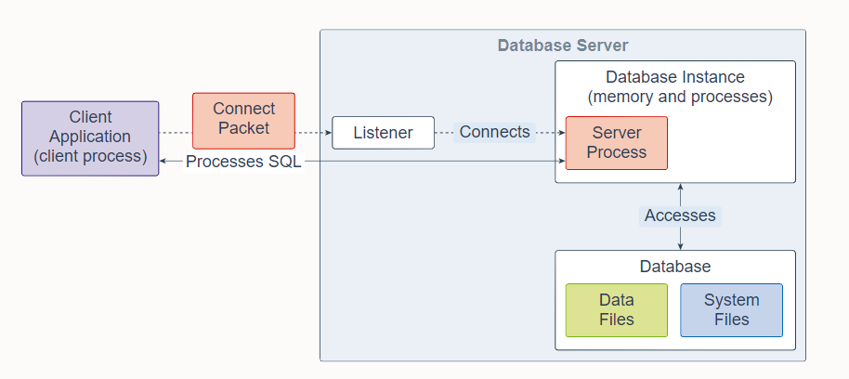An Oracle Real Application Clusters (Oracle RAC) database architecture consist of multiple instances that run on separate server machines. All of them share the same database. The cluster of server machines appears as a single server on one end, and end users and applications on the other end.

An Oracle Database consists of at least one database instance and one database. The database instance handles memory and processes. The database consists of physical files called data files, and can be a non-container database or a multitenant container database. An Oracle Database also uses several database system files during its operation.

A single-instance database architecture consists of one database instance and one database. A one-to-one relationship exists between the database and the database instance. Multiple single-instance databases can be installed on the same server machine. There are separate database instances for each database. This configuration is useful to run different versions of Oracle Database on the same machine.

An Oracle Real Application Clusters (Oracle RAC) database architecture consists of multiple instances that run on separate server machines. All of them share the same database. The cluster of server machines appears as a single server on one end, and end users and applications on the other end. This configuration is designed for high availability, scalability, and high-end performance.

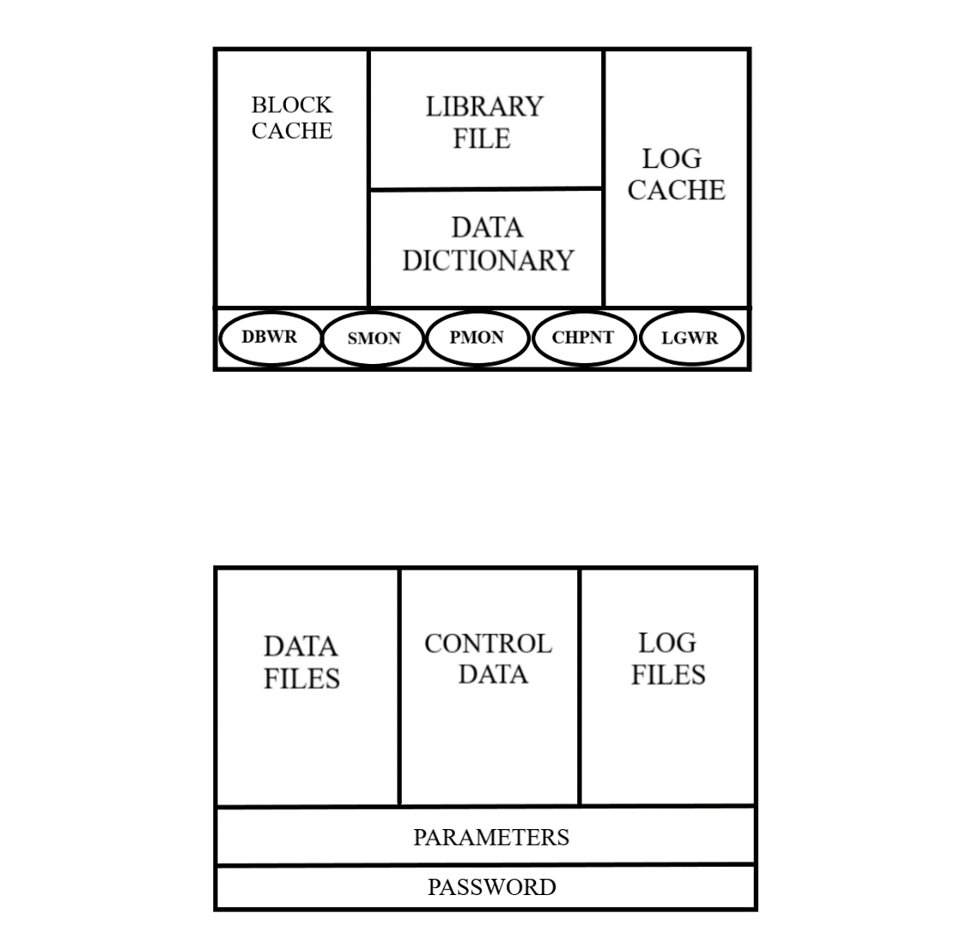

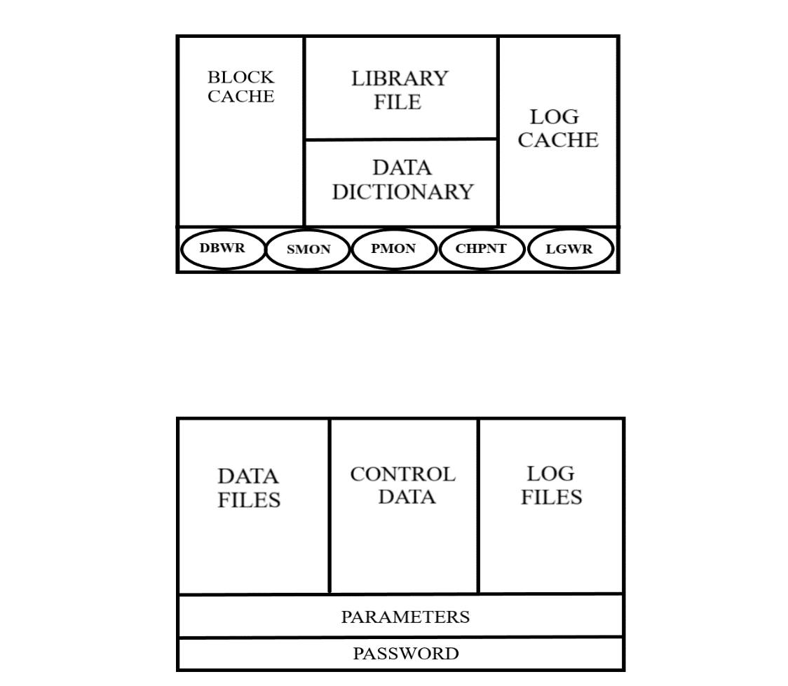

**COMPONENTS OF STORAGE IN ORACLE ARCHITECTURE:**

**Data File** : All tables and relationships between the tables is stored here.

**Control Data** : All the System files are stored.

**Log files** : All logs are stored here.

**Parameters :** Values of various parameters like block size are stored here.

**Password** : Password of all users are stored here.

**COMPONENTS OF MEMORY IN ORACLE ARCHITECTURE:**

**Block cache** : Data retrieved from files is stored here.

**Library files** : All commands and Syntax are stored here for verification.

**Data dictionary** : Meta data is stored here.

**Log cache** : Log of all operation is stored here before data is commited.

**Checkpoint**: It syncronises LGWR and DBWR.

**DBWR** (Database Writer) : It fetches data from data files & writes it to block cache.

**SMON** (System monitor) : It monitors the system.

**PMON** (Process Monitor) : It monitors ongoing processes.

**LGWR** (Log Writer) : It fetches log from log cache & writes it to log files after data is committed.

**CONCLUSION:**

In this practical we learned about Oracle Architecture

**PRACTICAL – 2**

**Aim: To study DDL-create and DML-insert commands.**

1. **Create tables according to the following definition.**

* CREATE TABLE DEPOSIT (ACTNO VARCHAR2(5), CNAME VARCHAR2(18), BNAME VARCHAR2(18), AMOUNT NUMBER (8,2), ADATE DATE);
* CREATE TABLE BRANCH (BNAME VARCHAR2(18), CITY VARCHAR2(18));
* CREATE TABLE CUSTOMERS (CNAME VARCHAR2(19), CITY VARCHAR2(18));
* CREATE TABLE BORROW (LOANNO VARCHAR2(5), CNAME VARCHAR2(18), BNAME VARCHAR2(18), AMOUNT NUMBER (8,2));

1. **Insert the data as shown below.**

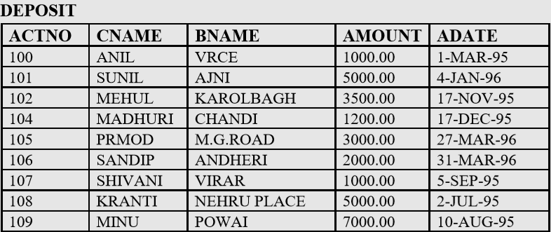

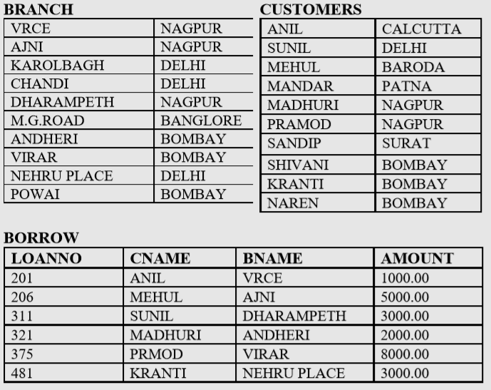

**From the above given tables perform the following queries:**

**Hardware Required:** Computer/Laptop

**Software Required:** Oracle

**Knowledge Required:** Oracle Architecture.

**Program**:

1. DESCRIBE DEPOSIT, BRANCH.

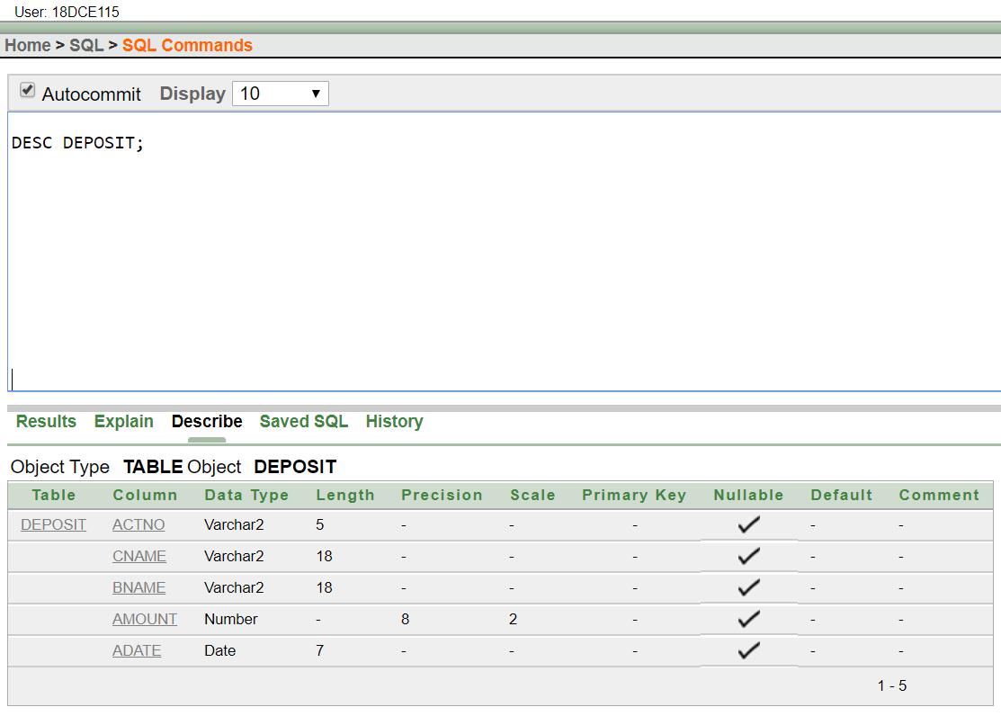

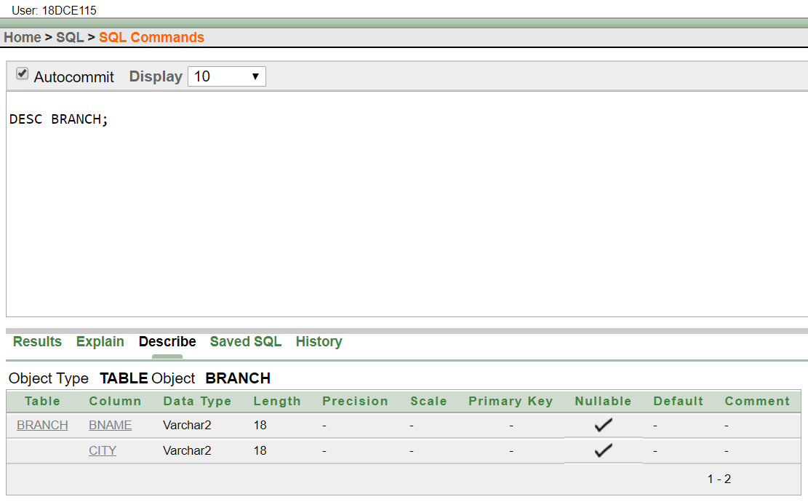

1. DESCRIBE BORROW, CUSTOMERS.

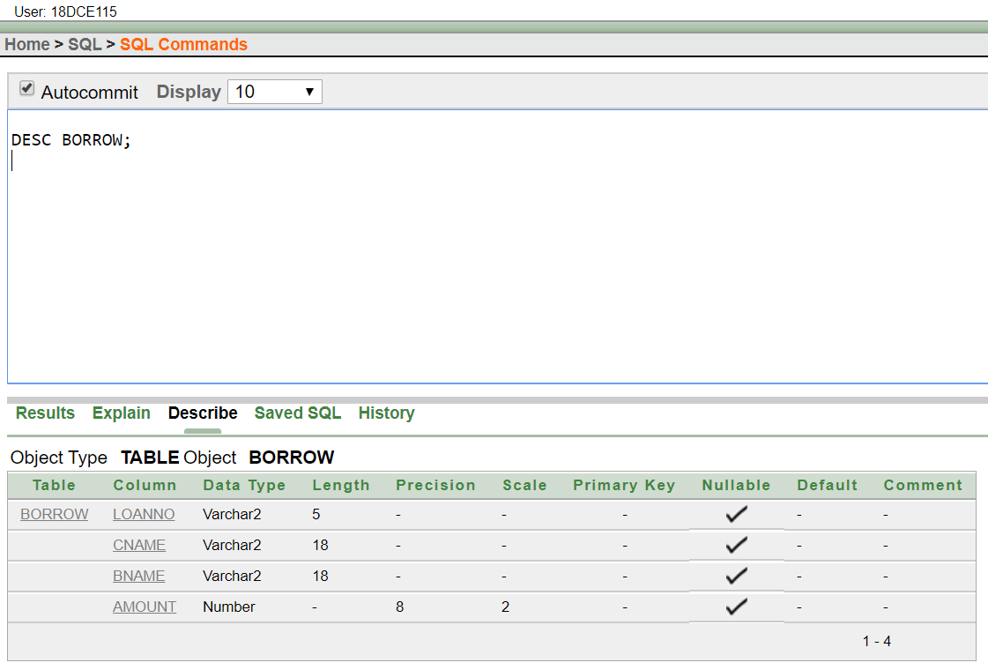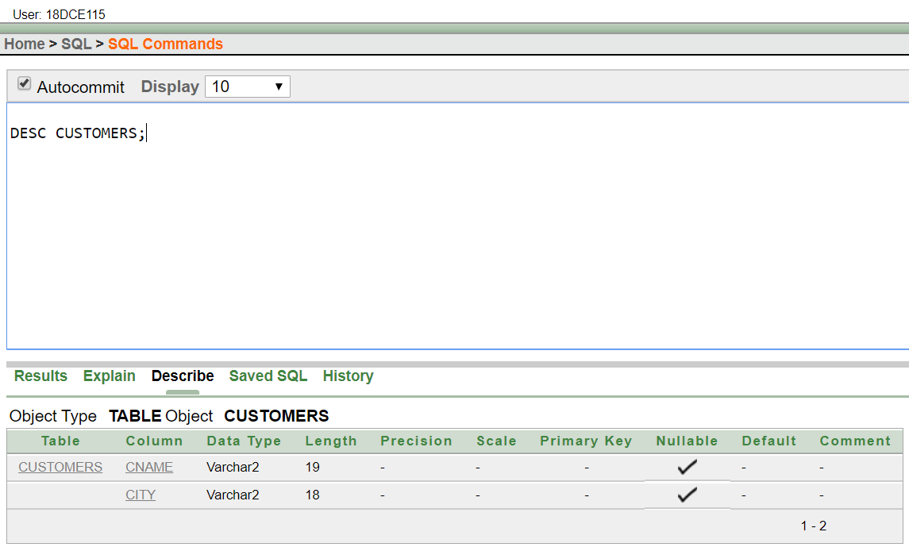

1. LIST ALL DATA FROM TABLE DEPOSIT1.

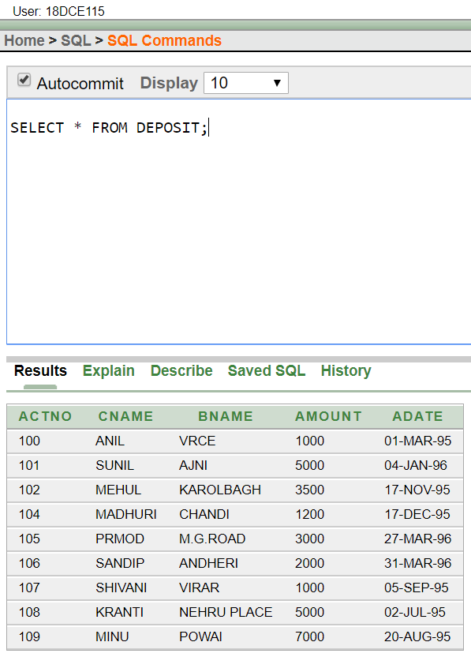

1. LIST ALL DATA FROM TABLE BORROW1.

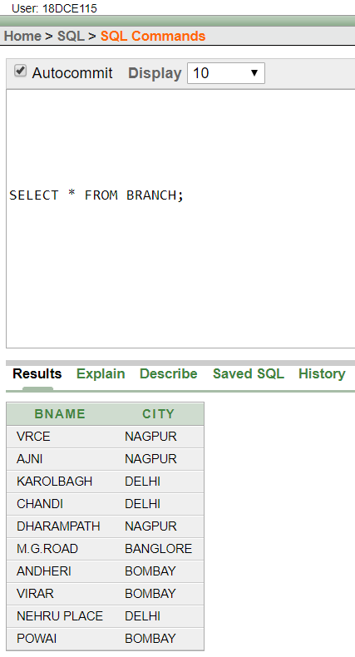

1. LIST ALL DATA FROM TABLE CUSTOMERS.



1. LIST ALL DATA FROM TABLE BRANCH.

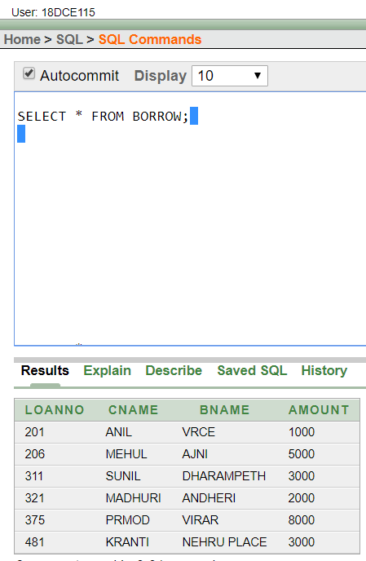

1. GIVE ACCOUNT NO AND AMOUNT OF DEPOSITORS.

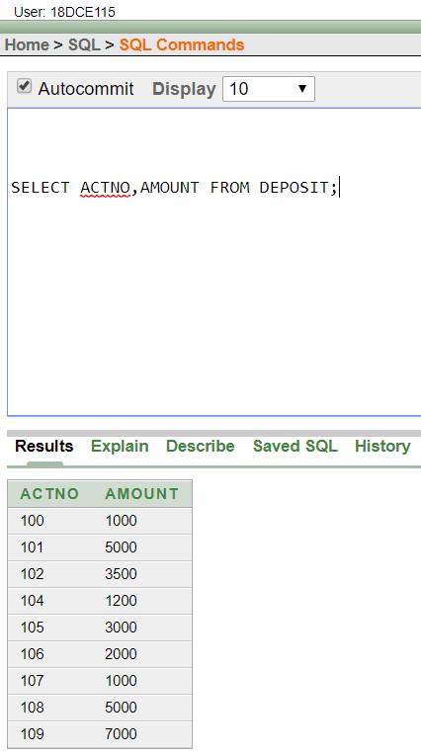

1. GIVE NAME OF DEPOSITORS HAVING AMOUNT GREATER THAN 4000.

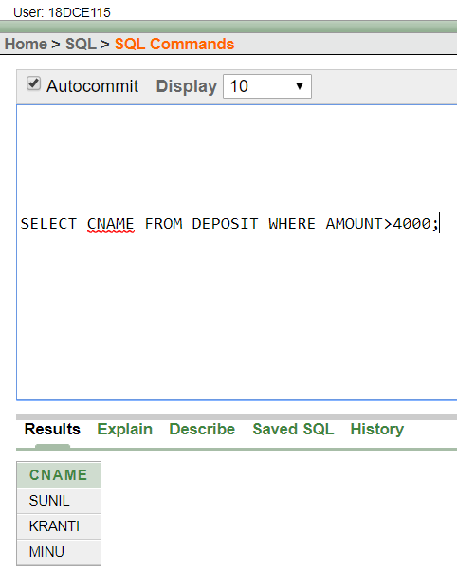

1. GIVE NAME OF CUSTOMERS WHO OPENED ACCOUNT AFTER DATE '1-12-95'.

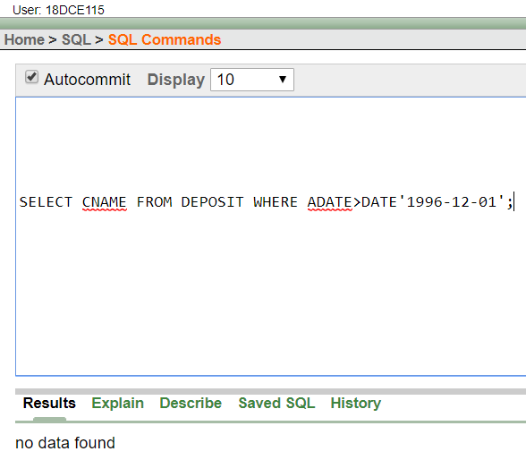

1. GIVE NAME OF CITY WHERE BRANCH KAROLBAGH IS LOCATED.

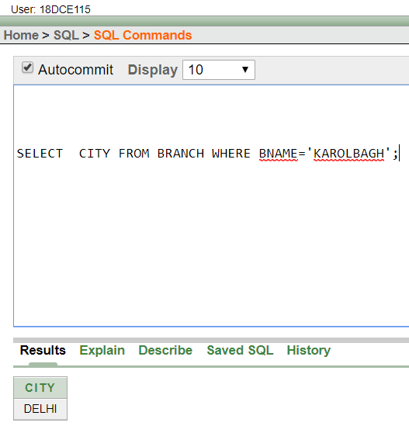

1. GIVE ACCOUNT NO AND AMOUNT OF CUSTOMER HAVING ACCOUNT OPENED BETWEEN DATE 1-6-95 AND 1-12-95

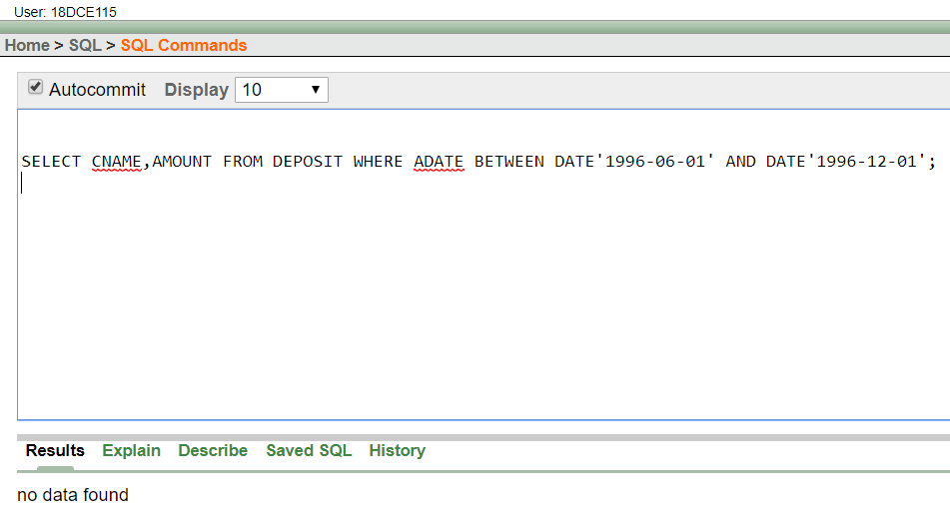

1. GIVE NAMES OF DEPOSITORS HAVING ACCOUNT AT VRCE.

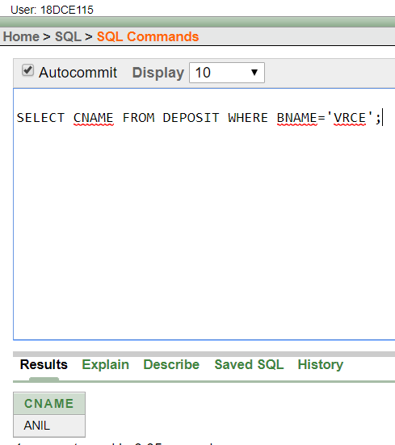

**Question/ Answers**

Q.1) What is a DDL command?

Ans. DDL or Data Definition Language actually consists of the SQL commands that can be used to define the database schema. It simply deals with descriptions of the database schema and is used to create and modify the structure of database objects in the database.

Q.2) What is a DML command?

Ans. DML is short name of Data Manipulation Language which deals with data manipulation and includes most common SQL statements such SELECT, INSERT, UPDATE, DELETE, etc., and it is used to store, modify, retrieve, delete and update data in a database

**Conclusion:**

In this practical we learned about DDL and DML commands

**PRACTICAL – 3**

**Aim: Create the below given table and insert the data accordingly.**

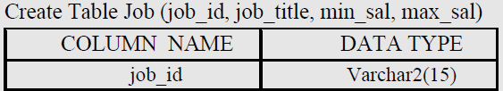

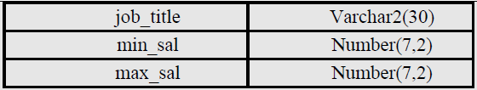

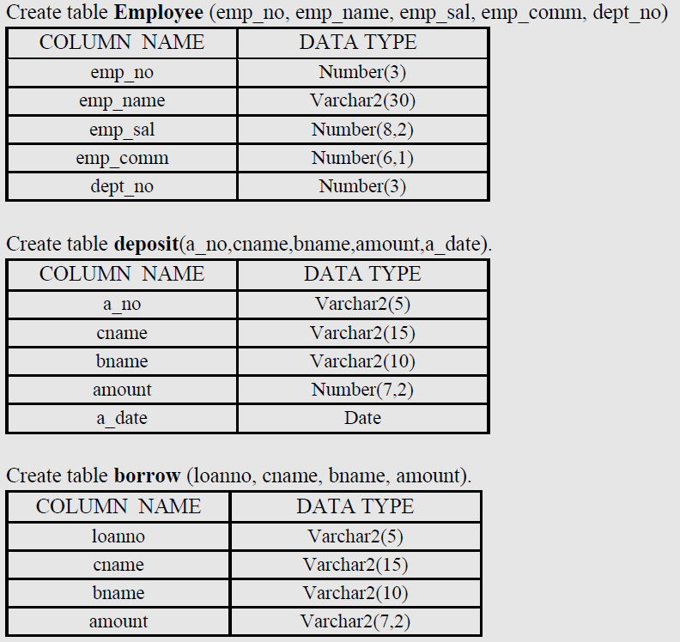

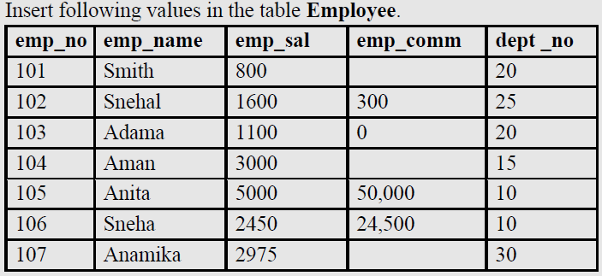

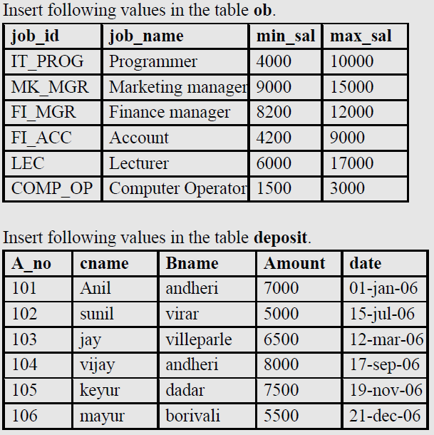

**Hardware Required:** Computer/Laptop

**Software Required:** Oracle 10g Exe

**Knowledge Required:** DDL-create and DML-insert commands and LIKE predicates.

**Perform Following queries:**

1. RETRIEVE ALL DATA FROM EMPLOYEE, JOBS AND DEPOSIT2.

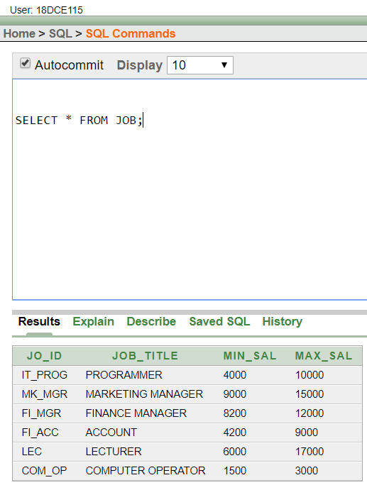

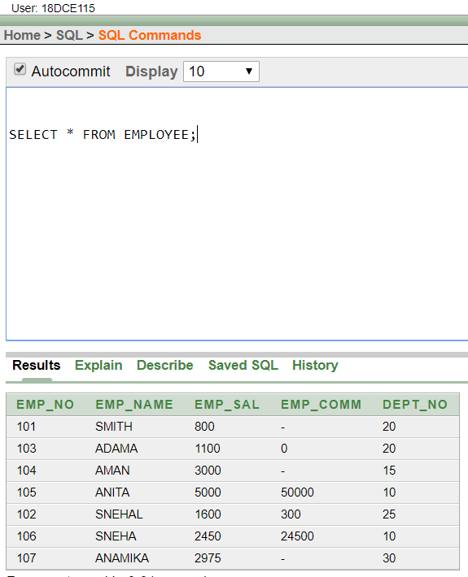

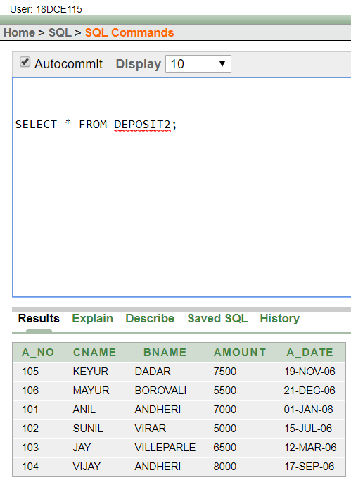

1. GIVE DETAILS OF ACCOUNT NO. AND DEPOSITED RUPEES OF CUSTOMERS HAVING ACCOUNT OPENED BETWEEN DATES 01-01-06 AND 25-07-06.

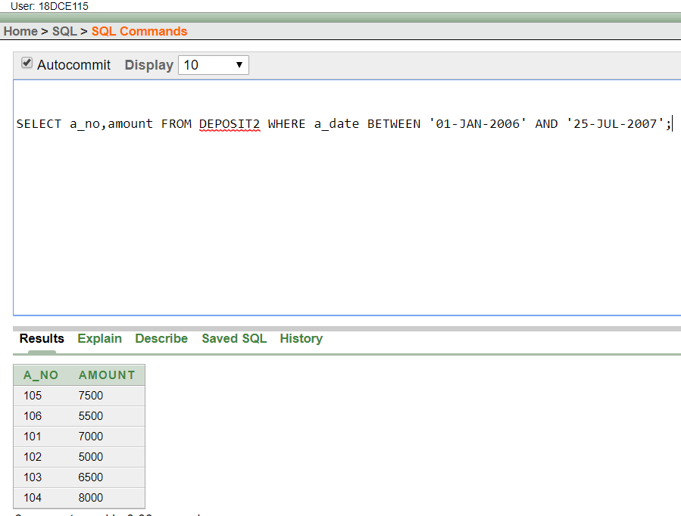

1. DISPLAY ALL JOBS WITH MINIMUM SALARY IS GREATER THAN 4000.

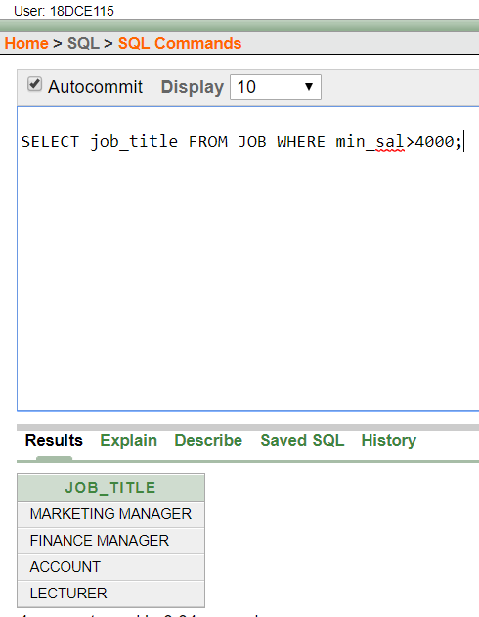

1. DISPLAY NAME AND SALARY OF EMPLOYEE WHOSE DEPARTMENT NO IS 20. GIVE ALIAS NAME TO NAME OF EMPLOYEE.

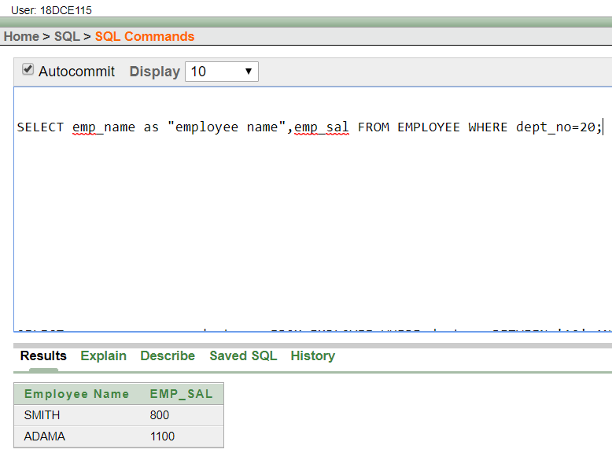

1. DISPLAY EMPLOYEE NO, NAME AND DEPARTMENT DETAILS OF THOSE EMPLOYEE WHOSE DEPARTMENT LIES IN (10,20).

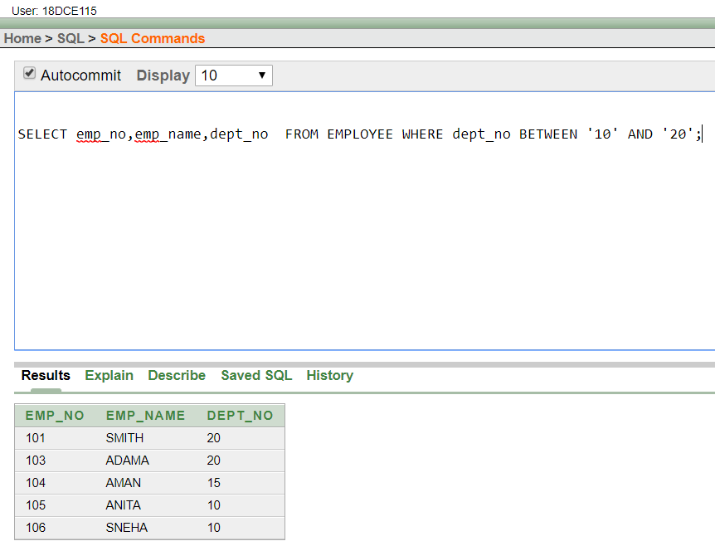

1. DISPLAY THE NON-NULL VALUES OF EMPLOYEES.

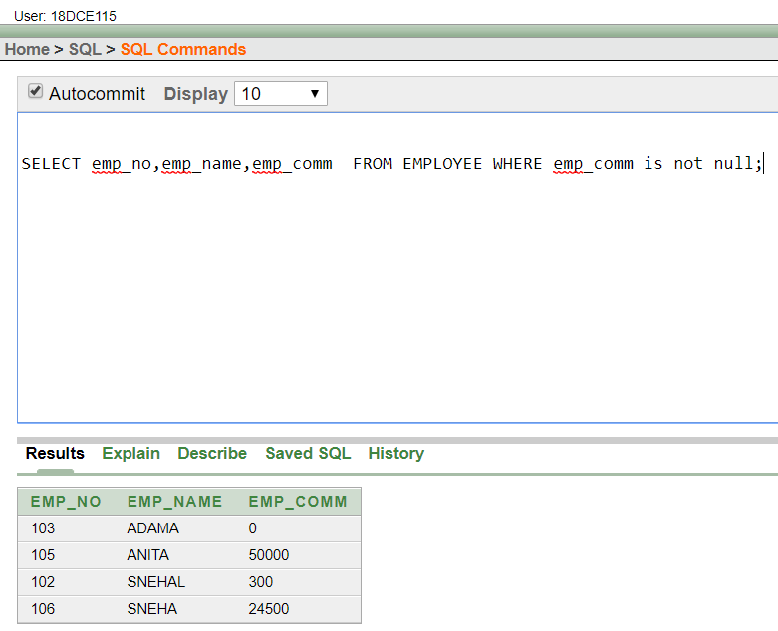

1. DISPLAY NAME OF CUSTOMER ALONG WITH ITS ACCOUNT NO (BOTH COLUMNS SHOULD BE DISPLAYED AS ONE) WHOSE AMOUNT IS NOT EQUAL TO 8000 RS.

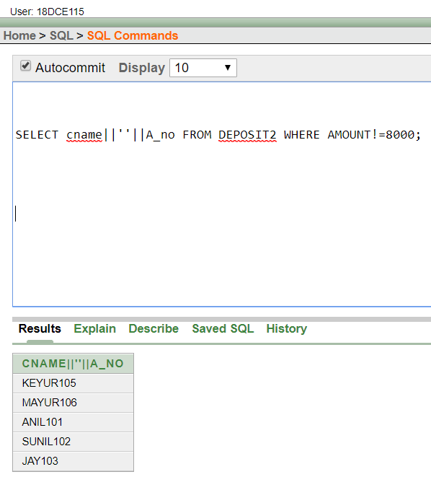

1. DISPLAY THE CONTENT OF JOB DETAILS WITH MINIMUM SALARY EITHER 2000 OR 4000.

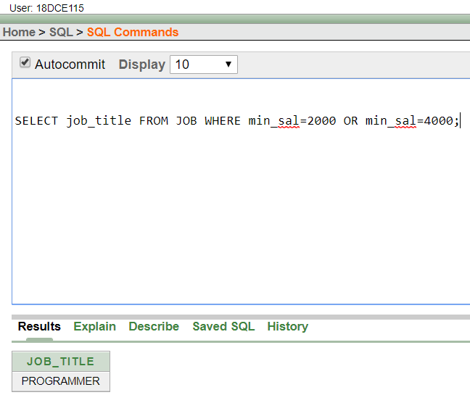

**To study various options of LIKE predicate**

(1) DISPLAY ALL EMPLOYEE WHOSE NAME START WITH ‘A’ AND THIRD CHARACTER IS ‘‘A’.

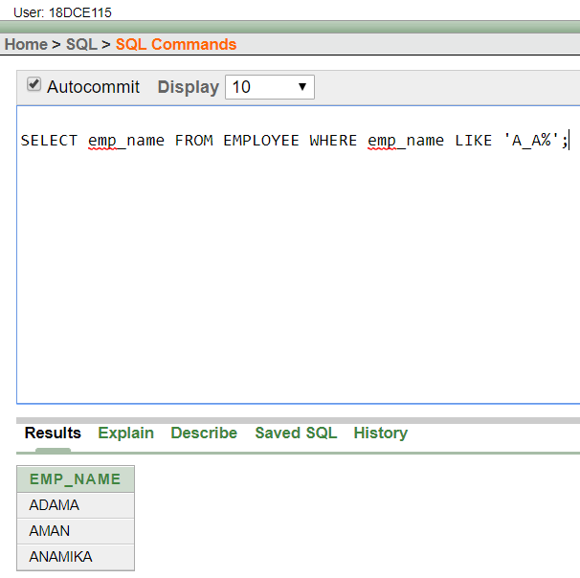

(2) DISPLAY NAME, NUMBER AND SALARY OF THOSE EMPLOYEES WHOSE NAME IS 5 CHARACTERS LONG AND FIRST THREE CHARACTERS ARE ‘ANI’.

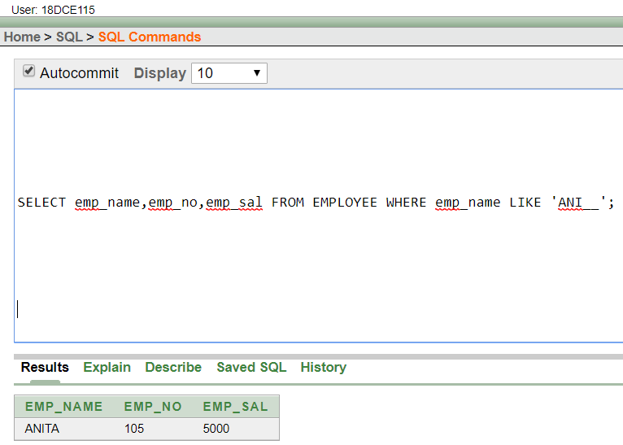

(3) DISPLAY ALL INFORMATION OF EMPLOYEE WHOSE SECOND CHARACTER OF NAME IS EITHER ‘M’ OR ‘N’.

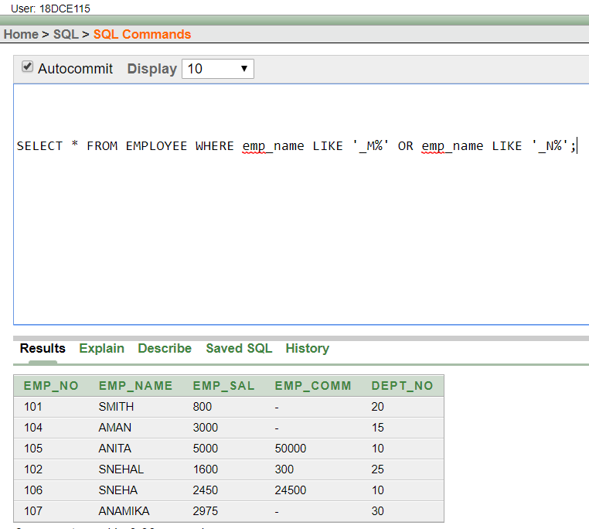

(4) FIND THE LIST OF ALL CUSTOMER NAME WHOSE BRANCH IS IN ‘ANDHERI’ OR ‘DADAR’ OR ‘VIRAR’.

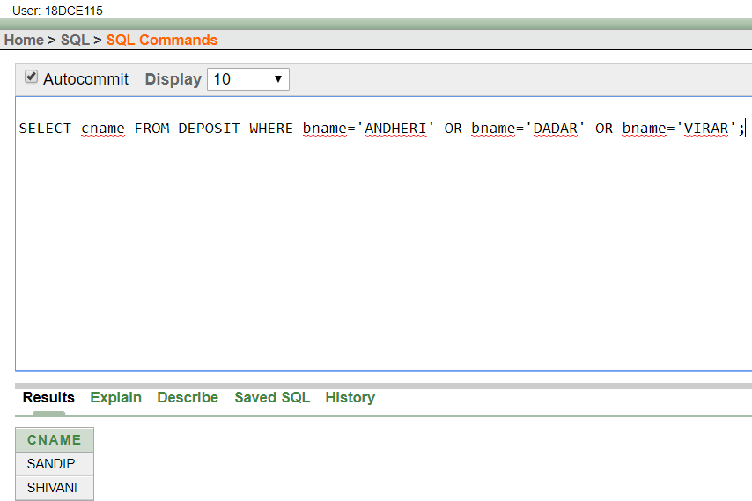

(5) DISPLAY THE JOB NAME WHOSE FIRST 3 CHAR. IN JOB ID FIELD IS ‘FI_’.

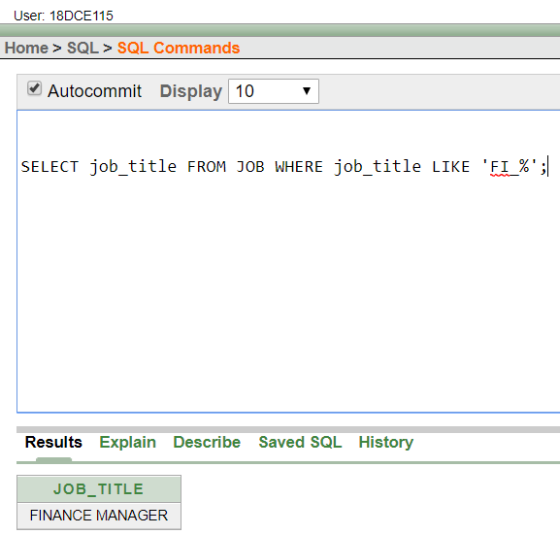

(6) DISPLAY THE TITLE/NAME OF JOB WHO’S LAST THREE CHARACTER ARE ‘_MGR’ AND THEIR MAXIMUM SALARY IS GREATER THAN RS 12000.

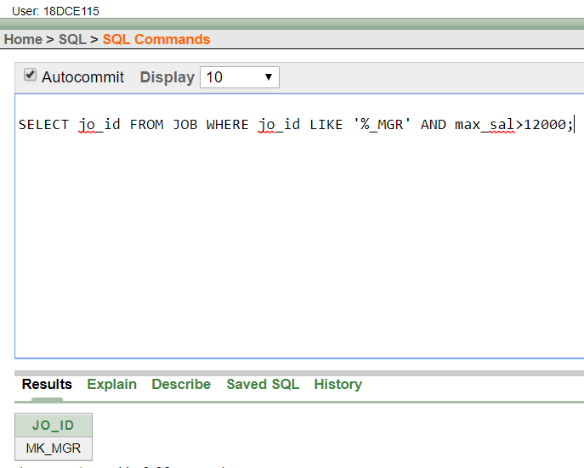

(7) DISPLAY THE NON-NULL VALUES OF EMPLOYEES AND ALSO EMPLOYEE NAME SECOND CHARACTER SHOULD BE ‘N’ AND STRING SHOULD BE 5-CHARACTER LONG.

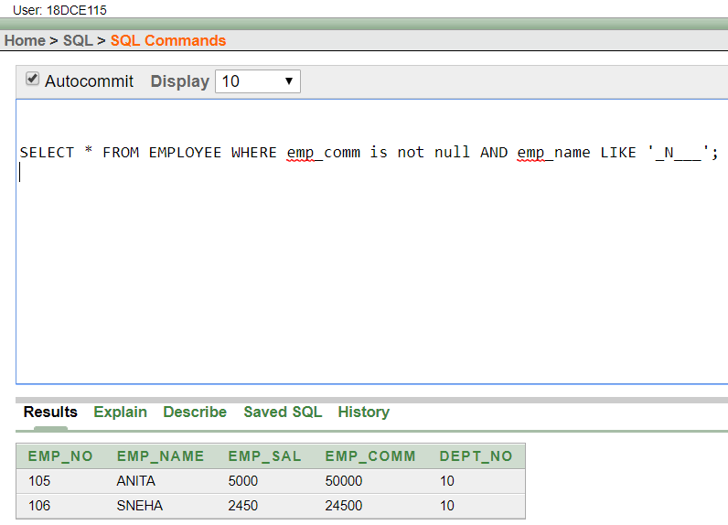

(8) DISPLAY THE NULL VALUES OF EMPLOYEE AND ALSO EMPLOYEE NAME’S

THIRD CHARACTER SHOULD BE ‘A’.

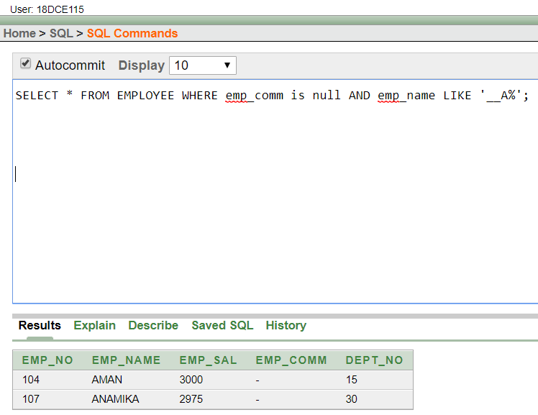

1. WHAT WILL BE OUTPUT IF YOU ARE GIVING LIKE PREDICATE AS ‘%\_%’ ESCAPE ‘\’ .

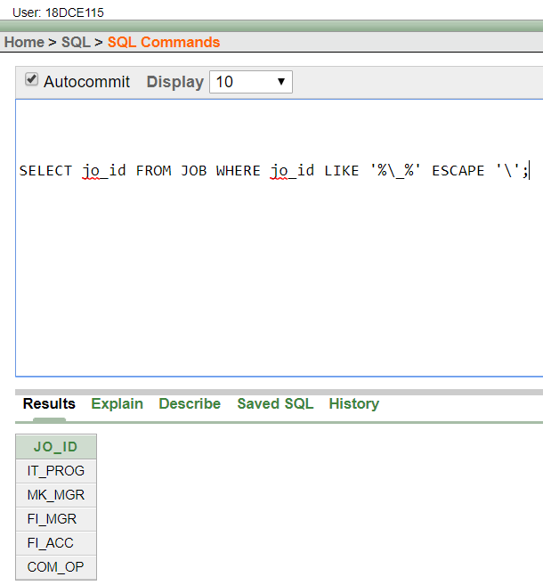

**Question/Answers**

Q.1) What is a like predicate?

Ans. The LIKE predicate compares a column of type CHAR or VARCHAR (string) with a pattern. This pattern is also a string, but it may contain two characters with a special meaning. The '_' (underscore) represents exactly one arbitrary character and '%' (percent) represents a string of zero, one or more characters

**CONCLUSION:**

In this practical we learned about DDL and DML commands in deep and we learned the concepts of LIKE predicates in DBMS.

**PRACTICAL – 4**

**Aim:** To Perform various data manipulation commands, aggregate functions and sorting concept on all created tables.

**Hardware Required:** Computer/Laptop

**Software Required:** Oracle 10g Exe

**Knowledge Required:** Data manipulation commands, aggregate functions and sorting concept

**PROGRAM:**

1. LIST TOTAL DEPOSIT FROM DEPOSIT.

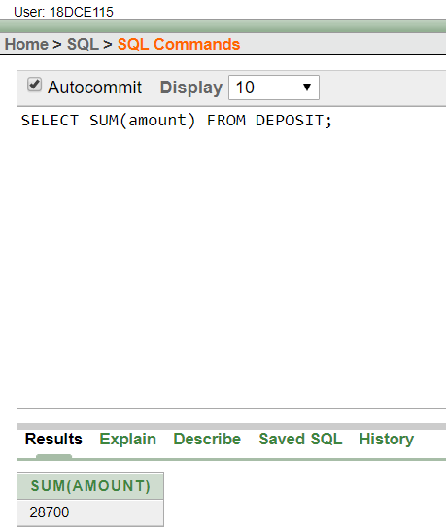

1. LIST TOTAL LOAN FROM KAROLBAGH BRANCH

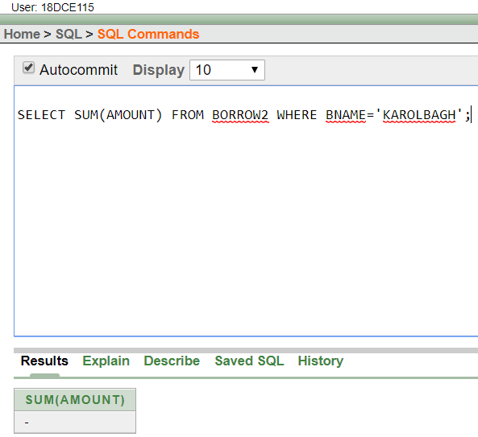

(3) GIVE MAXIMUM LOAN FROM BRANCH VRCE.

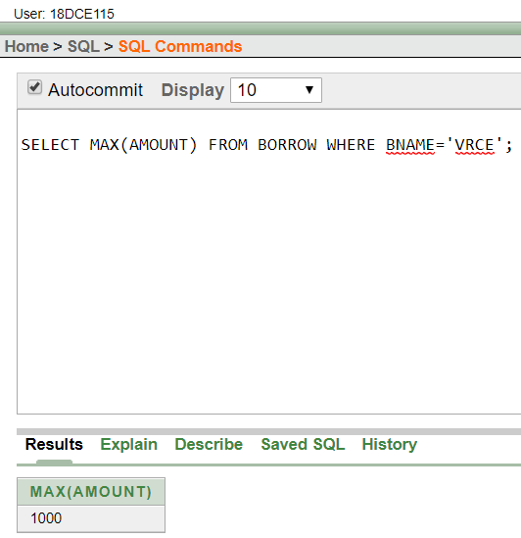

(4) COUNT TOTAL NUMBER OF CUSTOMERS

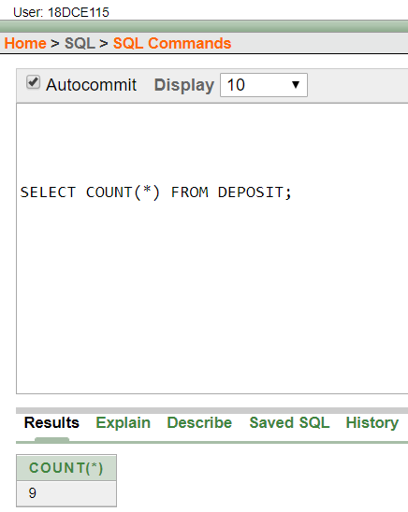

(5) COUNT TOTAL NUMBER OF CUSTOMER’S CITIES.

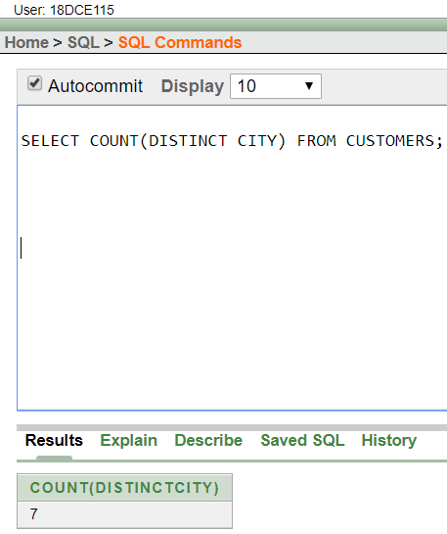

(6) CREATE TABLE SUPPLIER FROM EMPLOYEE WITH ALL THE COLUMNS.

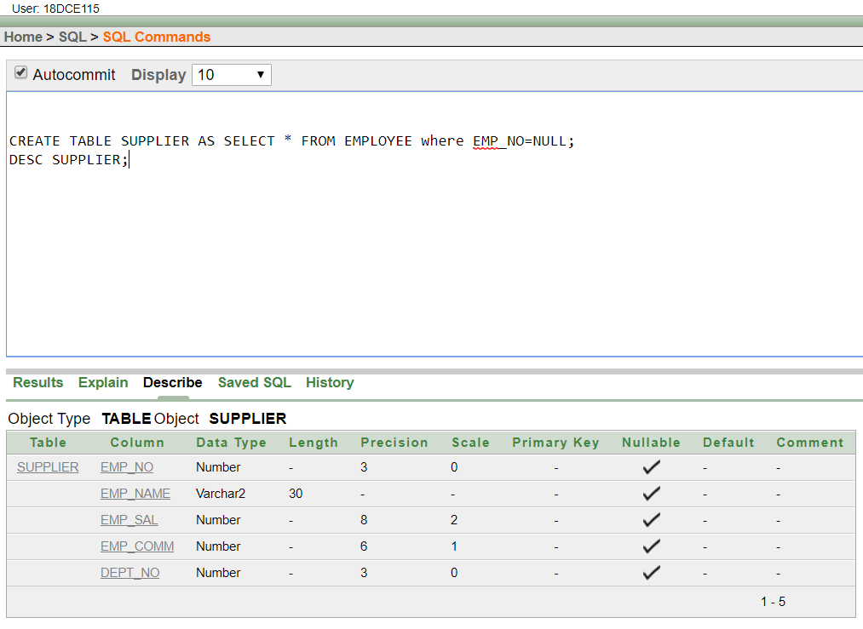

(7) CREATE TABLE SUP1 FROM EMPLOYEE WITH FIRST TWO COLUMNS.

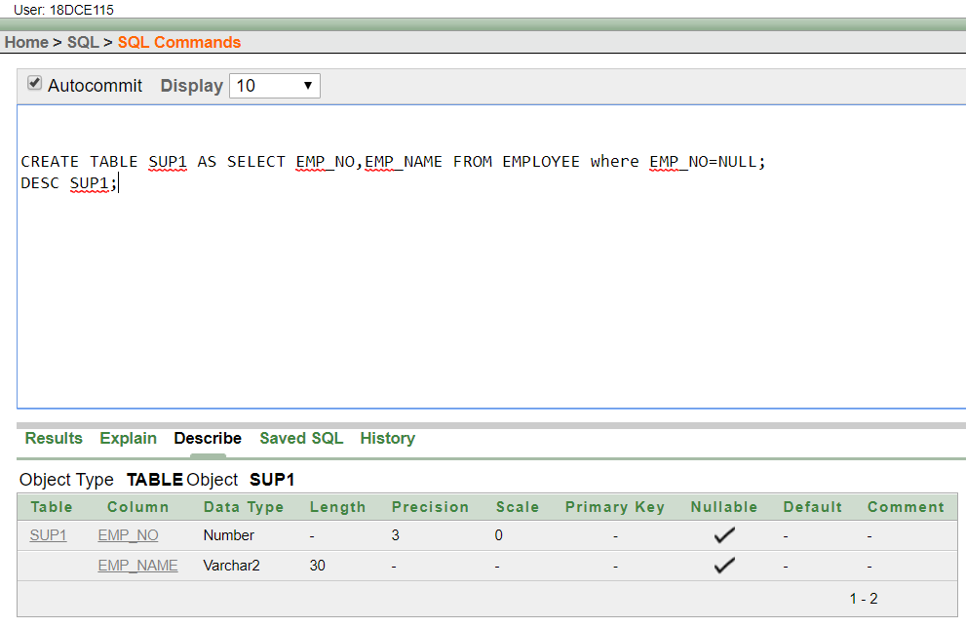

(8) CREATE TABLE SUP2 FROM EMPLOYEE WITH NO DATA

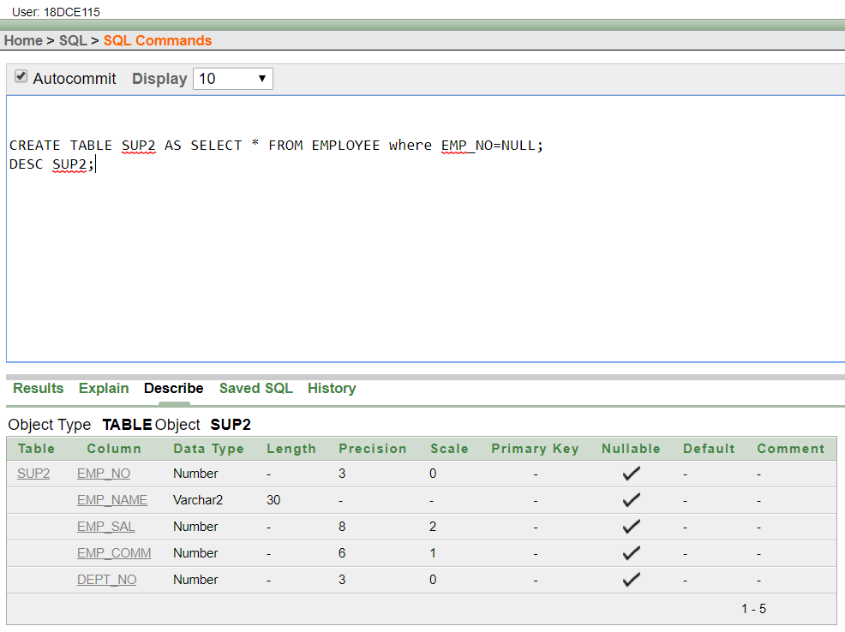

1. INSERT THE DATA INTO SUP2 FROM EMPLOYEE WHOSE SECOND CHARACTER SHOULD BE ‘N’ AND STRING SHOULD BE 5 CHARACTERS LONG IN EMPLOYEE NAME FIELD.

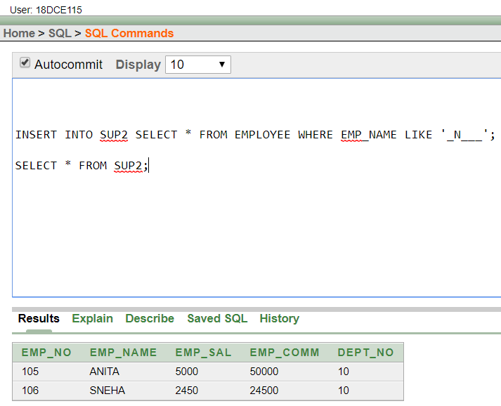

(10) DELETE ALL THE ROWS FROM SUP1.

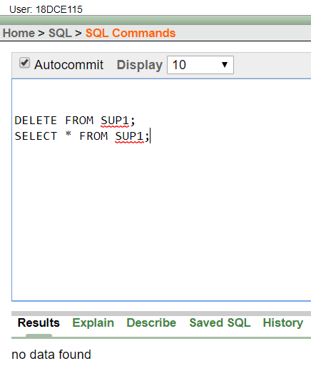

(11) DELETE THE DETAIL OF SUPPLIER WHOSE SUP_NO IS 103.

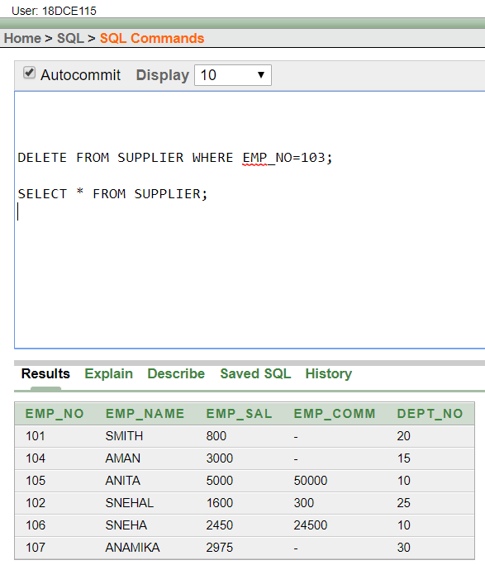

1. RENAME THE TABLE SUP2.

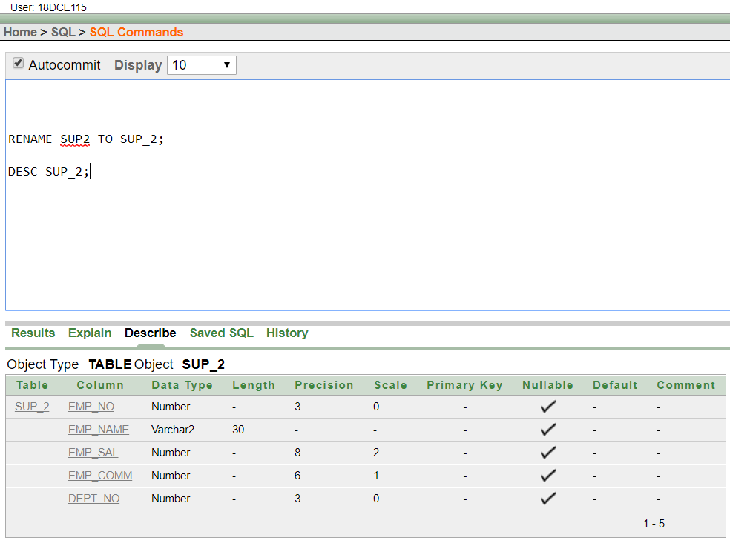

(13) DESTROY TABLE SUP1 WITH ALL THE DATA.

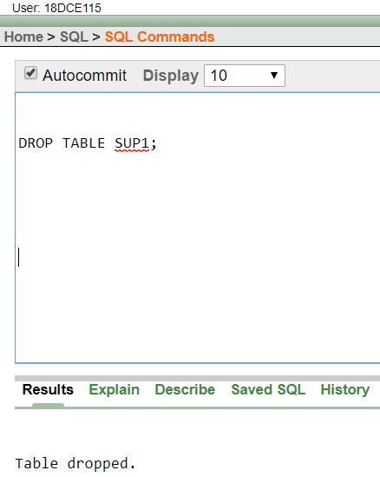

(14) UPDATE THE VALUE DEPT_NO TO 10 WHERE SECOND CHARACTER OF EMP. NAME IS ‘M’.

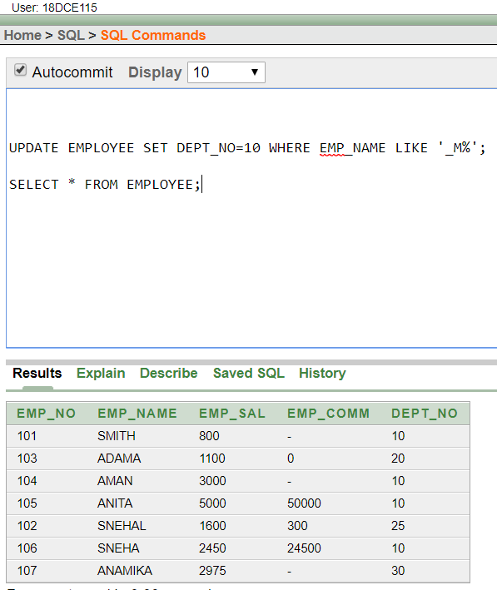

(15) UPDATE THE VALUE OF EMPLOYEE NAME WHOSE EMPLOYEE NUMBER IS 103.

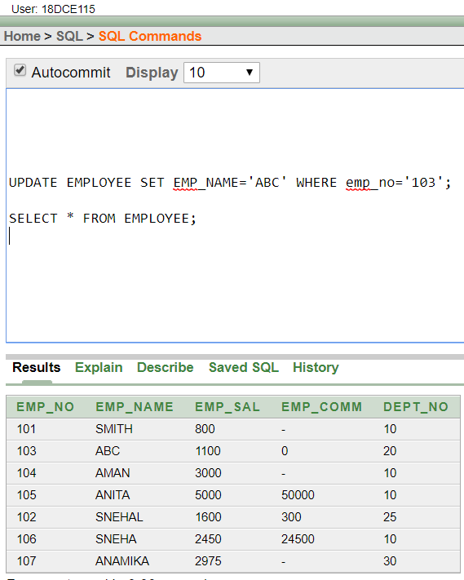

(16) ADD ONE COLUMN PHONE TO EMPLOYEE WITH SIZE OF COLUMN IS 10.

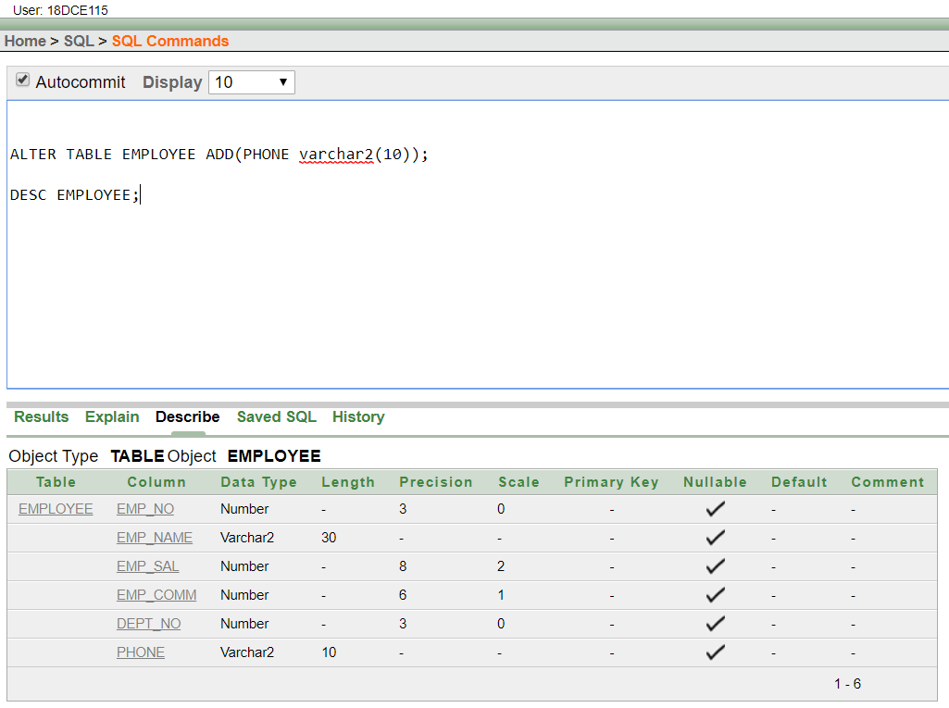

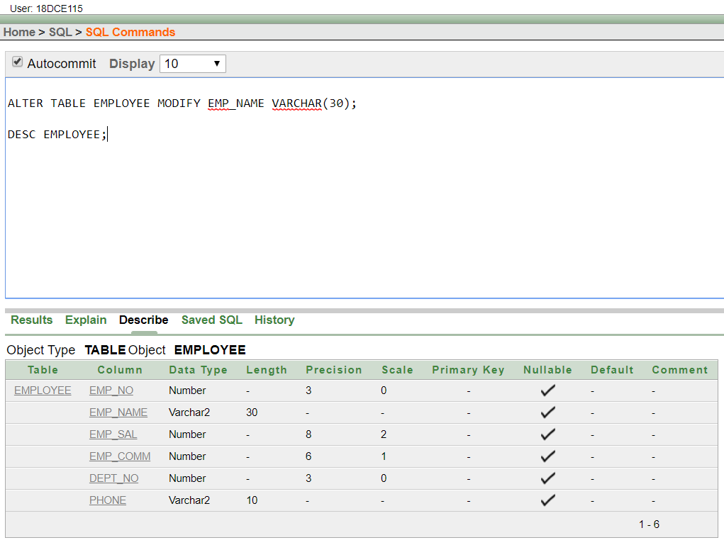

(17) MODIFY COLUMN EMP_NAME TO HOLD MAXIMUM OF 30 CHARACTERS.



(18) COUNT THE TOTAL NO AS WELL AS DISTINCT ROWS IN DEPT_NO COLUMN WITH A CONDITION OF SALARY GREATER THAN 1000 OF EMPLOYEE

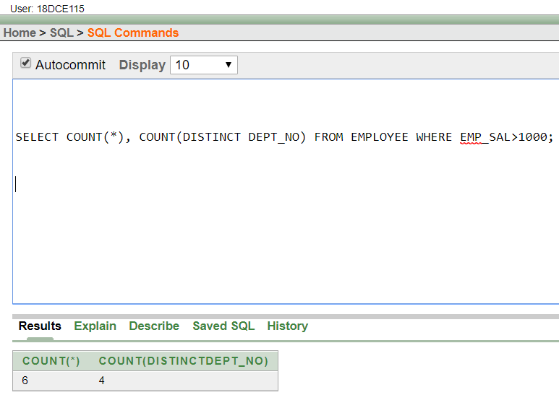

(19) DISPLAY THE DETAIL OF ALL EMPLOYEES IN ASCENDING ORDER, DESCENDING ORDER OF THEIR NAME AND NO.

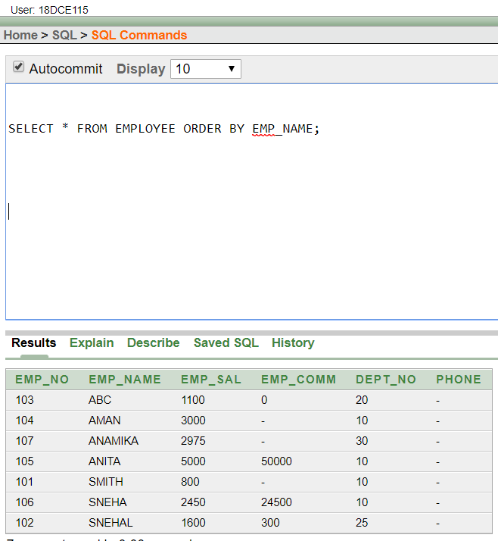

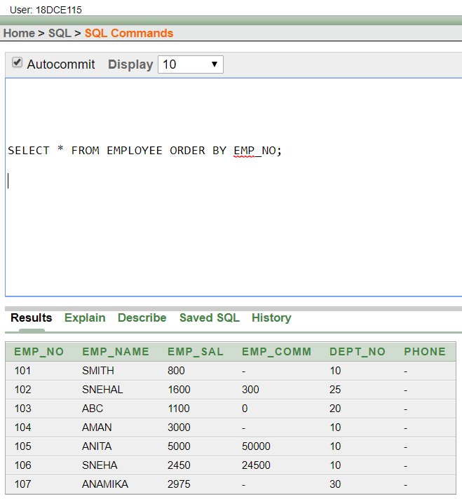

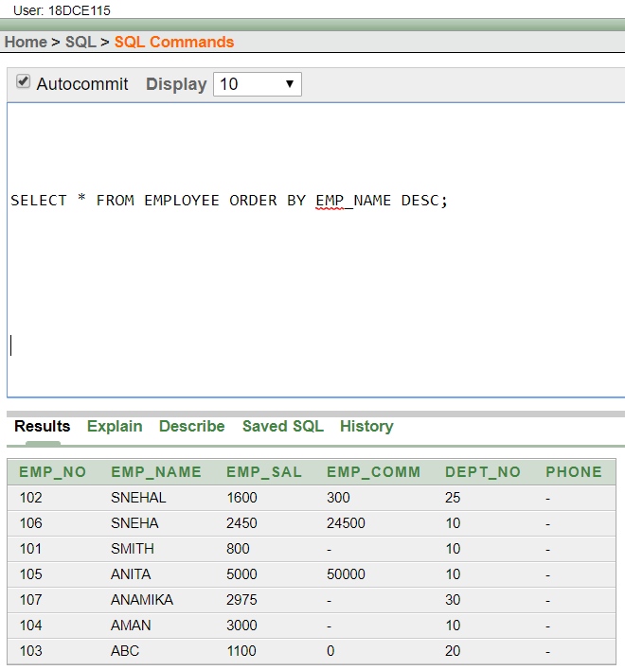

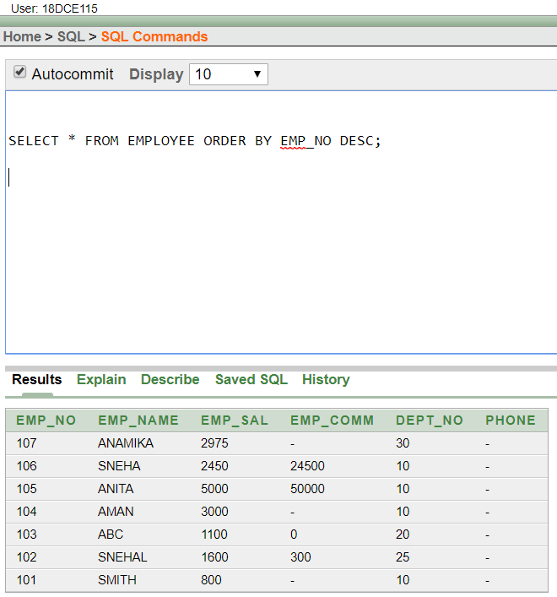

(20) DISPLAY THE DEPT_NO IN ASCENDING ORDER AND ACCORDINGLY DISPLAY EMP_COMM IN DESCENDING ORDER.

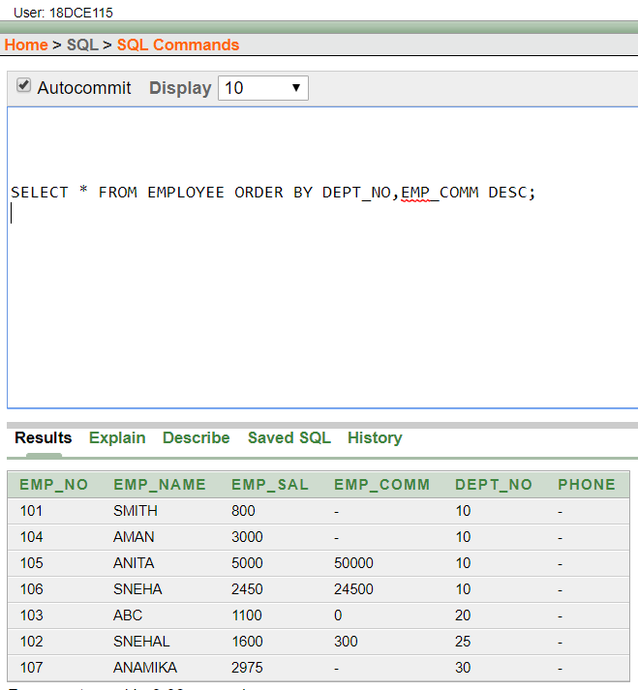

(21) UPDATE THE VALUE OF EMP_COMM TO 500 WHERE DEPT_NO IS 20.

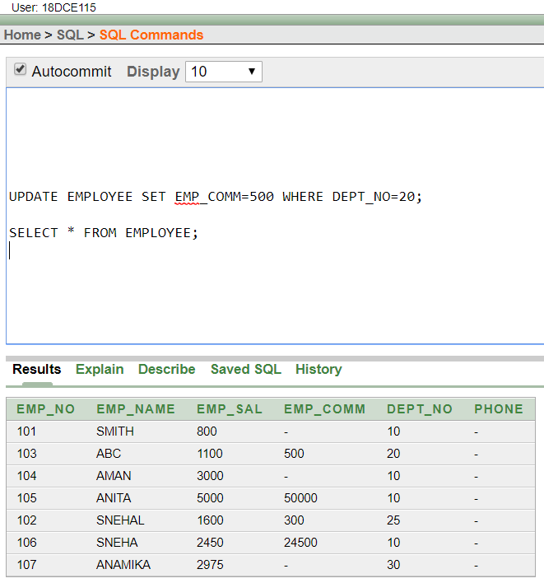

(22) DISPLAY THE EMP_COMM IN ASCENDING ORDER WITH NULL VALUE FIRST AND ACCORDINGLY SORT EMPLOYEE SALARY IN DESCENDING ORDER.

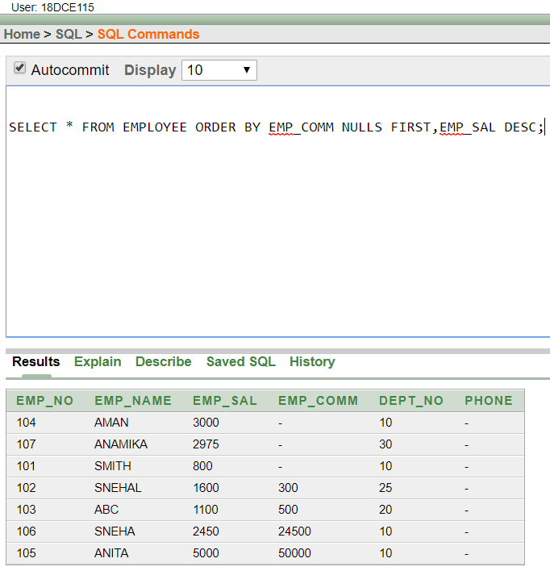

(23) DISPLAY THE EMP_COMM IN ASCENDING ORDER WITH NULL VALUE LAST AND ACCORDINGLY SORT EMP_NO IN DESCENDING ORDER.

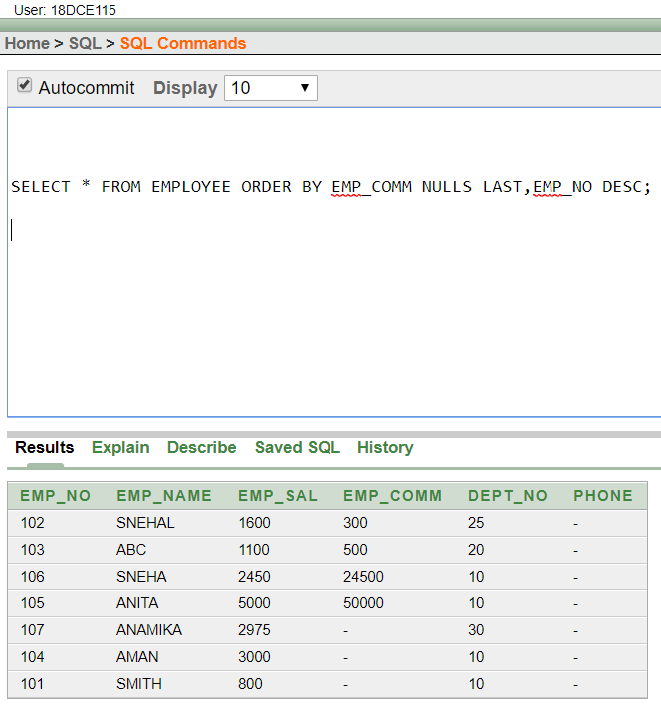

**Question/Answers:**

Q.1) What are data manipulation commands?

Ans. Data Manipulation commands as the name suggests are used to retrieve and manipulate data in a relational database. These are a part of Data Manipulation Language or DML. Second, comes the insert command which is used for inserting data into a table.

Q.2) What are Aggregate Functions?

Ans. In database management an aggregate function is a function where the values of multiple rows are grouped together as input on certain criteria to form a single value of more significant meaning.

Q.3) What are sorting concepts?

Ans. Sorting refers to the operation or technique of arranging and rearranging sets of data in some specific order. ... Sorting is the operation performed to arrange the records of a table or list in some order according to some specific ordering criterion. Sorting is performed according to some key value of each record.

**CONCLUSION**:

In this practical we learned about various data manipulation commands, aggregate functions and sorting concepts.

**PRACTICAL – 5**

**Aim: To Study Single-Row Functions.**

**Hardware Required:** Computer/Laptop

**Software Required:** Oracle 10g Exe

**Knowledge Required:** Row Functions

**PROGRAM:**

1. WRITE A QUERY TO DISPLAY THE CURRENT DATE. LABEL THE COLUMN DATE .

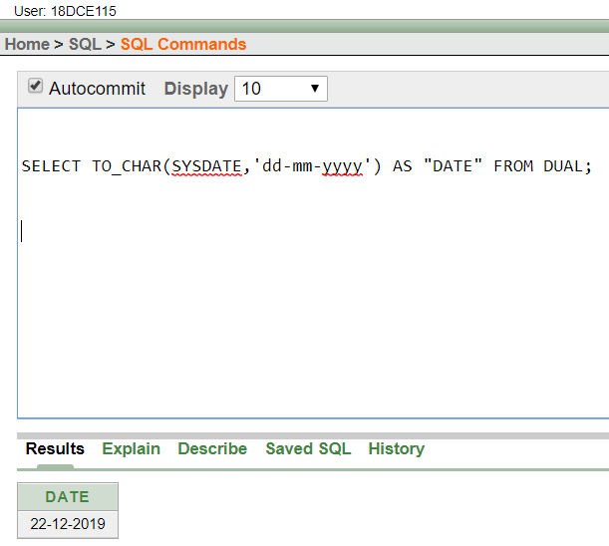

(2) FOR EACH EMPLOYEE, DISPLAY THE EMPLOYEE NUMBER, JOB, SALARY, AND SALARY INCREASED BY 15% AND EXPRESSED AS A WHOLE NUMBER. LABEL THE COLUMN NEW SALARY

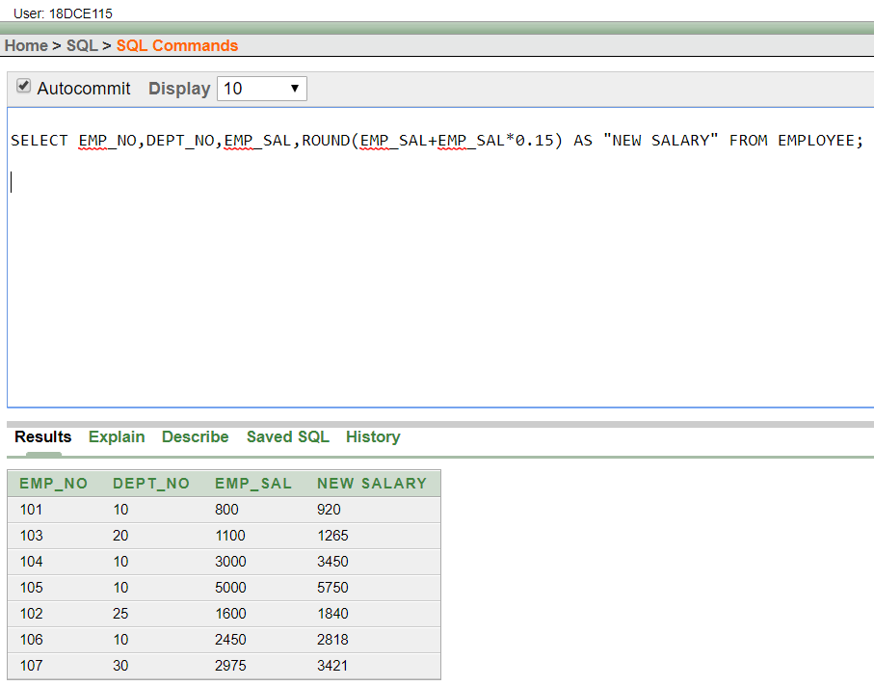

(3) MODIFY YOUR QUERY NO (2) TO ADD A COLUMN THAT SUBTRACTS THE OLD SALARY FROM THE NEW SALARY. LABEL THE COLUMN INCREASE

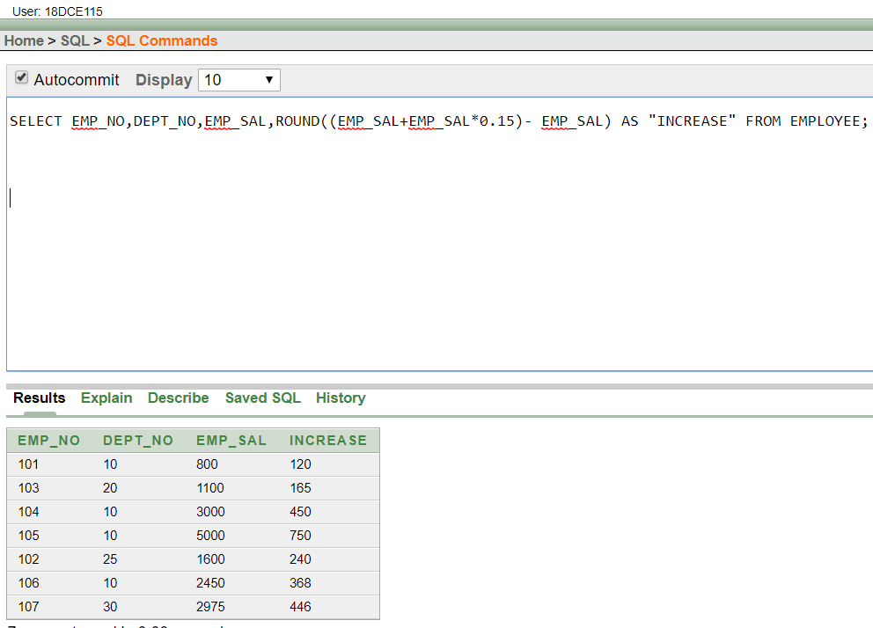

(4) WRITE A QUERY THAT DISPLAYS THE EMPLOYEE’S NAMES WITH THE FIRST LETTER CAPITALIZED AND ALL OTHER LETTERS LOWERCASE, AND THE LENGTH OF THE NAMES, FOR ALL EMPLOYEES WHOSE NAME STARTS WITH J, A, OR M. GIVE EACH COLUMN AN APPROPRIATE LABEL. SORT THE RESULTS BY THE EMPLOYEES NAMES.

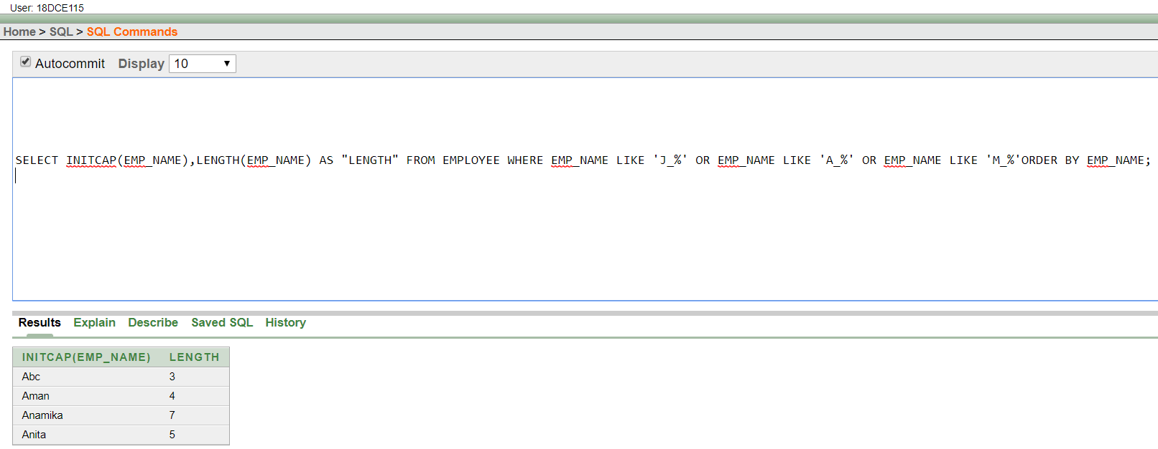

(5) WRITE A QUERY THAT PRODUCES THE FOLLOWING FOR EACH EMPLOYEE:

<EMPLOYEE LAST NAME> EARNS <SALARY> MONTHLY

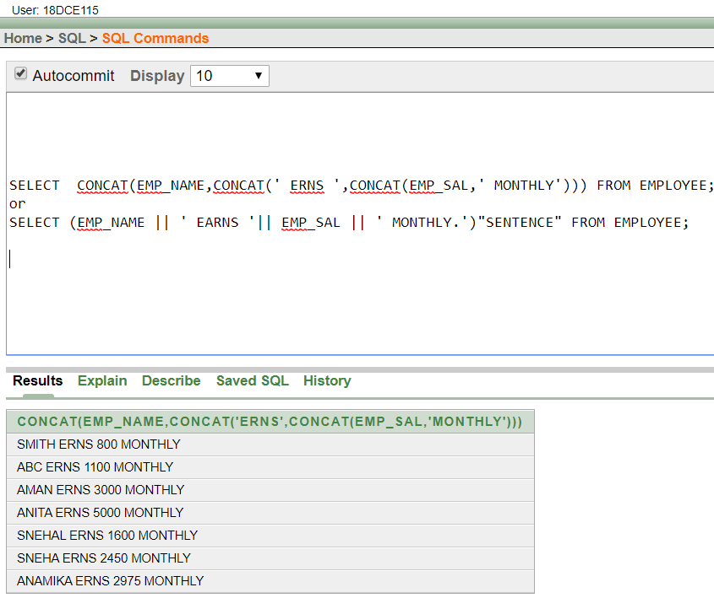

(6) DISPLAY THE NAME, HIRE DATE, NUMBER OF MONTHS EMPLOYED AND DAY OF THE WEEK ON WHICH THE EMPLOYEE HAS STARTED. ORDER THE RESULTS BY THE DAY OF THE WEEK STARTING WITH MONDAY.

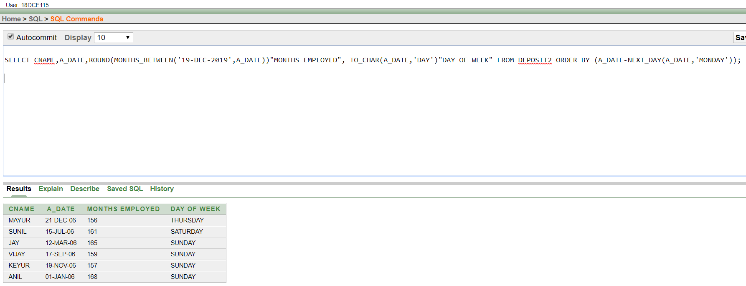

(7) DISPLAY THE HIREDATE OF EMP IN A FORMAT THAT APPEARS AS SEVENTH OF JUNE 1994 12:00:00 AM.

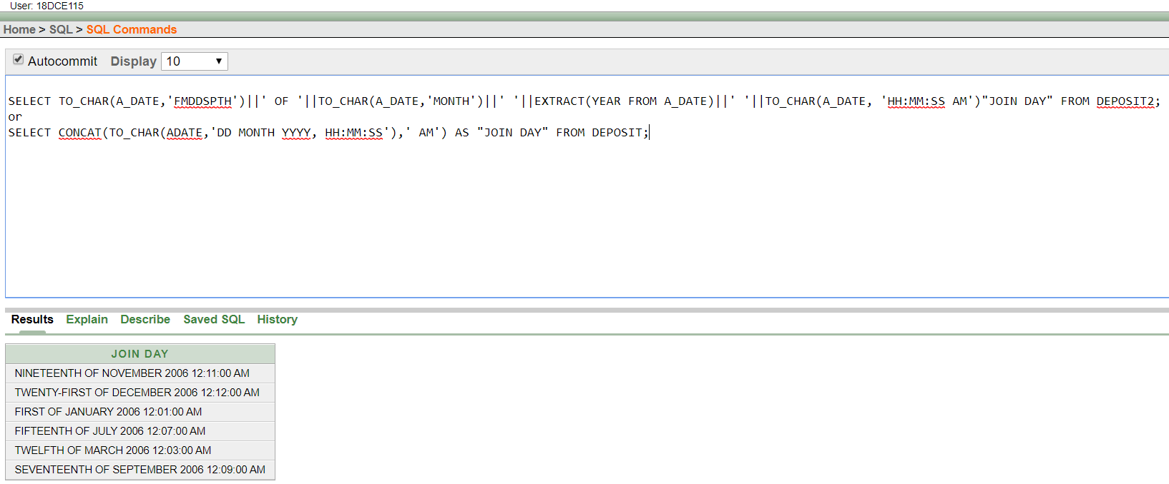

1. WRITE A QUERY TO CALCULATE THE ANNUAL COMPENSATION OF ALL EMPLOYEES (SAL +COMM.).

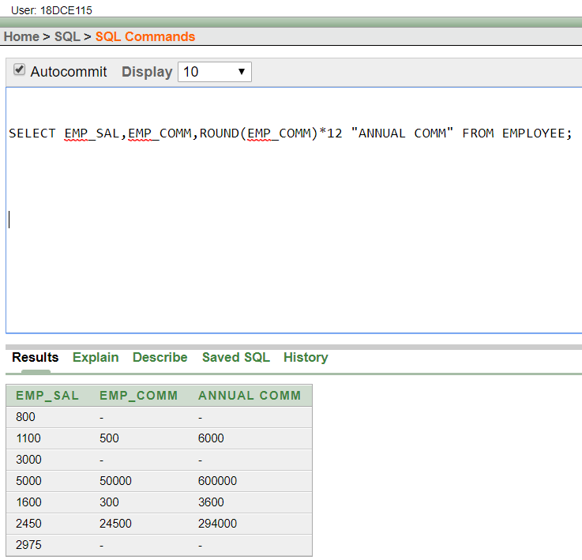

**Question/Answers**

Q.1) What are various row Functions?

Ans. Functions under the category are CONCAT, LENGTH, SUBSTR, INSTR, LPAD, RPAD, TRIM and REPLACE. CONCAT function concatenates two string values. ... INSTR function returns numeric position of a character or a string in a given string. LPAD and RPAD functions pad the given string upto a specific length with a given character.

**CONCLUSION:**

In this practical we learned about the various row functions in DBMS.

**PRACTICAL-6**

**Aim: Displaying data from Multiple Tables (join)**

**Hardware Required:** Computer/Laptop

**Software Required:** Oracle 10g Exe

**Knowledge Required:** Various Join Functions

**PROGRAM:**

1. Give details of customers ANIL.

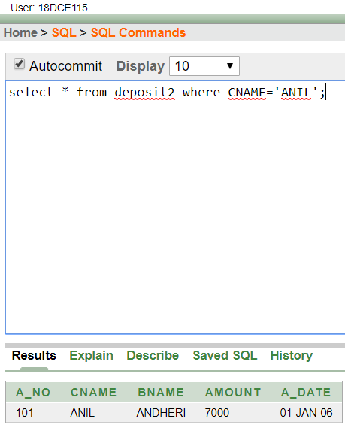

1. Give name of customer who are borrowers and depositors and having living city Nagpur.

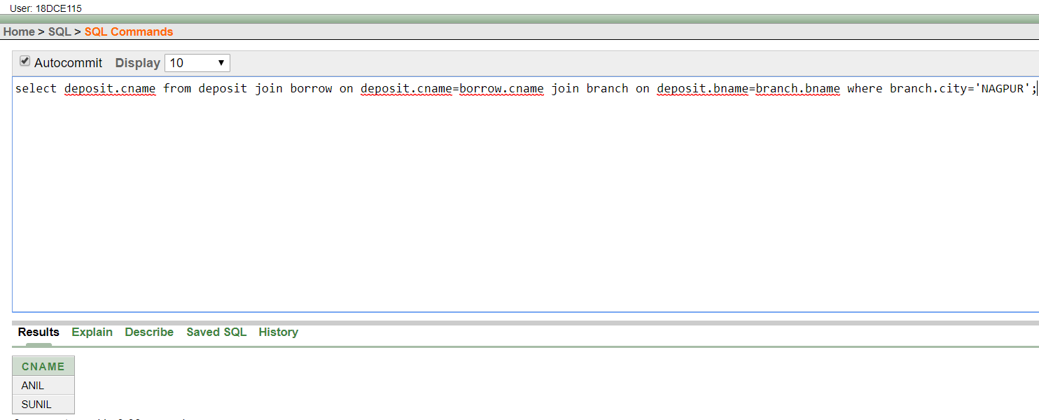

1. Give city as their city name of customers having same living branch.

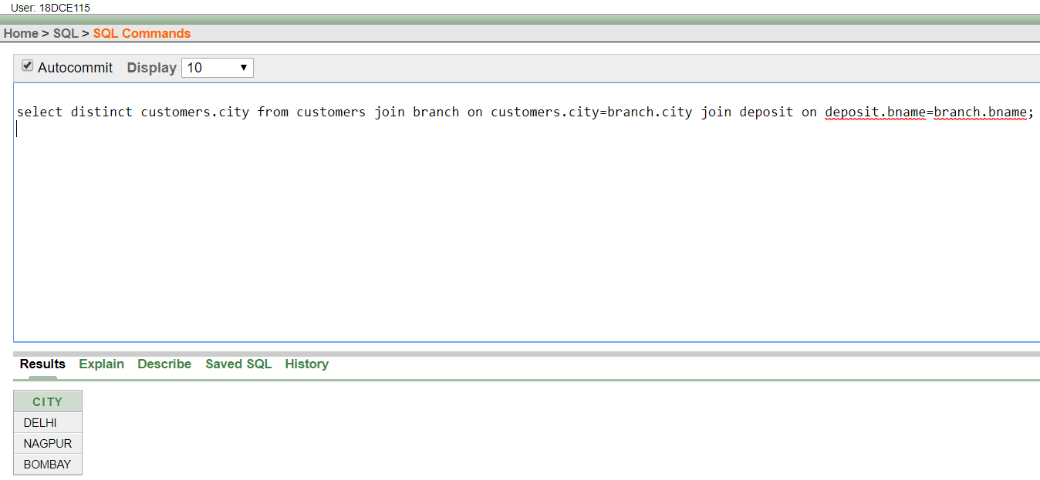

1. Write a query to display the last name, department number, and department name for all employees.

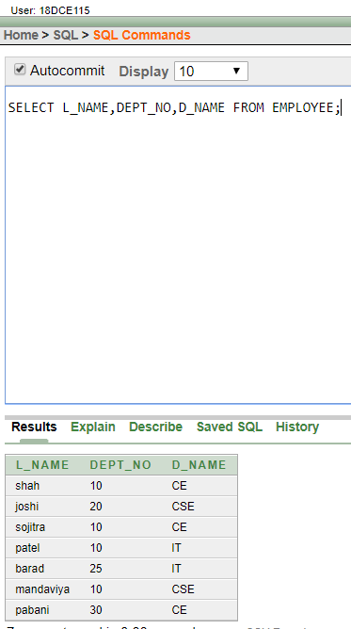

1. Create a unique listing of all jobs that are in department 30. Include the location of the department in the output.

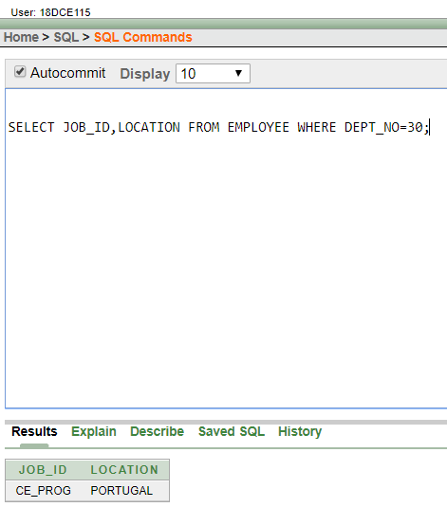

1. Write a query to display the employee name, department number, and department name for all employees who work in NEW YORK.

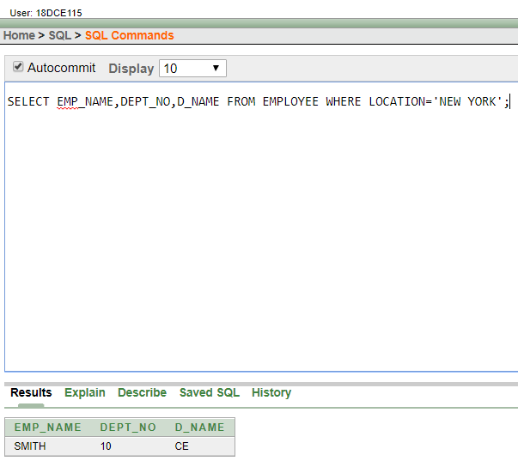

1. Display the employee last name and employee number along with their manager’s last name and manager number. Label the columns Employee, Emp#, Manager, and Mgr#, respectively.

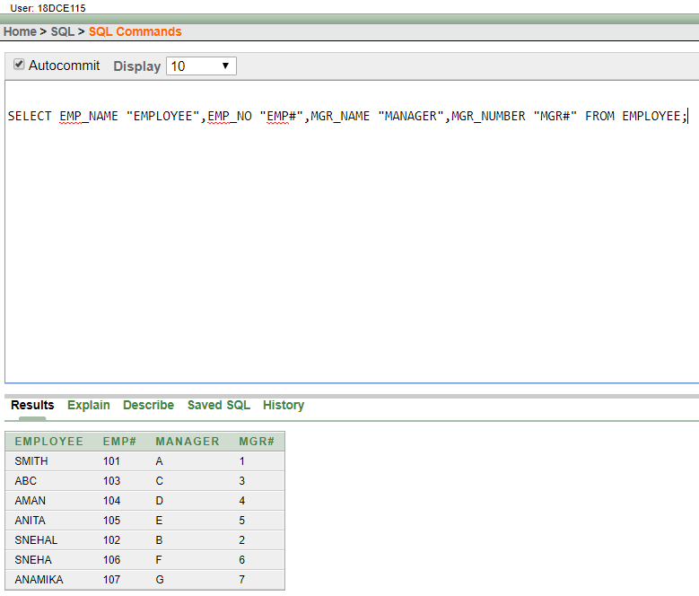

1. Create a query to display the name and hire date of any employee hired after employee SCOTT.

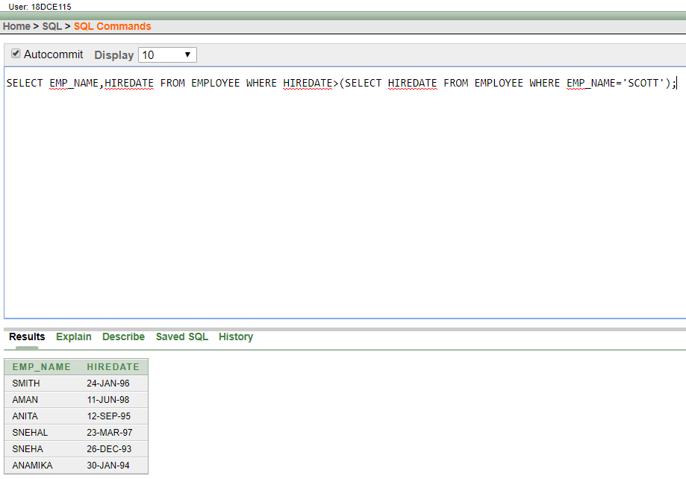

**Question/Answer**

Q.1) Which are various types of JOIN?

Ans. There are four basic types of SQL joins: inner, left, right, and full. The easiest and most intuitive way to explain the difference between these four types is by using a Venn diagram, which shows all possible logical relations between data sets.

**CONCLUSION:**

In this practical we learned about various types of JOIN function in DBMS

**PRACTICAL-7**

**Aim:** To apply the concept of Aggregating Data using Group functions.

**Hardware Required:** Computer/Laptop

**Software Required:** Oracle 10g Exe

**Knowledge Required:** Aggregating Data using Group functions

**PROGRAM:**

1. List total deposit of customer having account date after 1-jan-96.

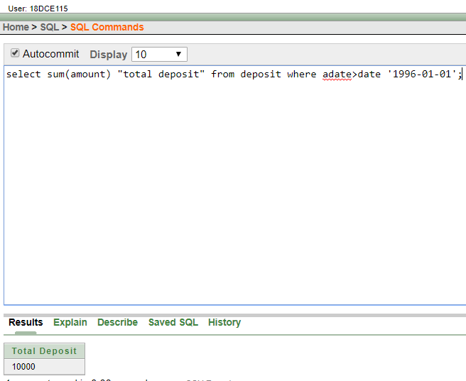

1. List total deposit of customers living in city Nagpur.

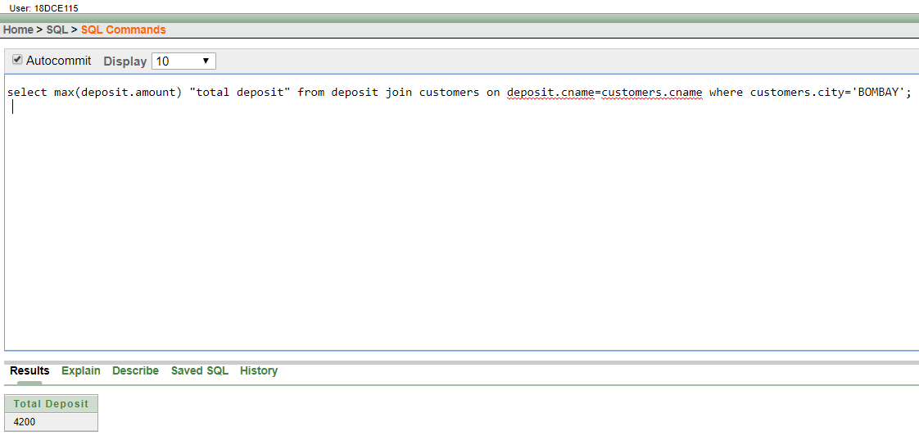

1. List maximum deposit of customers living in bombay.

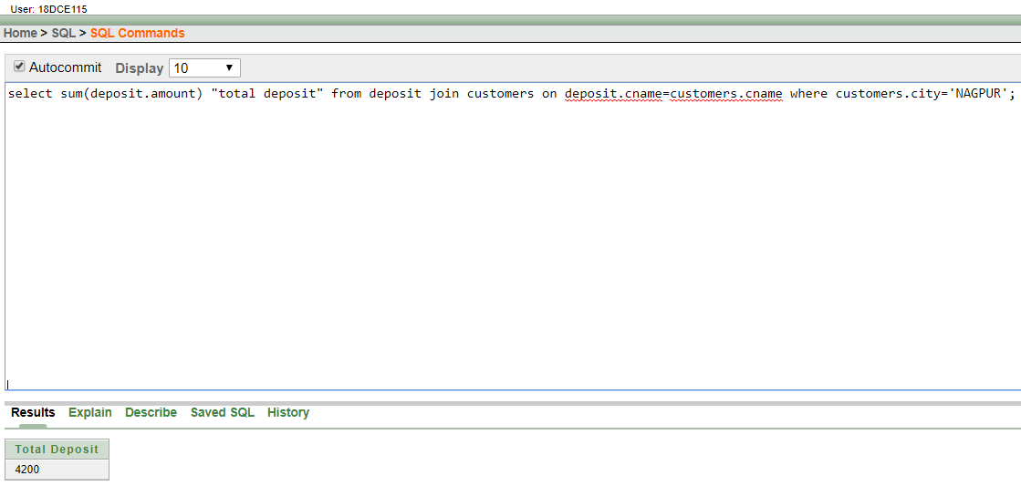

1. Display the highest, lowest, sum, and average salary of all employees. Label the columns Maximum, Minimum, Sum, and Average, respectively. Round your results to the nearest whole number.

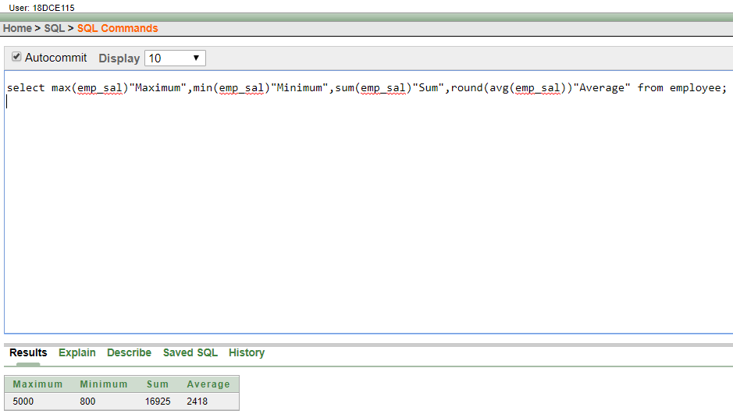

1. Write a query that displays the difference between the highest and lowest salaries. Label the column DIFFERENCE.

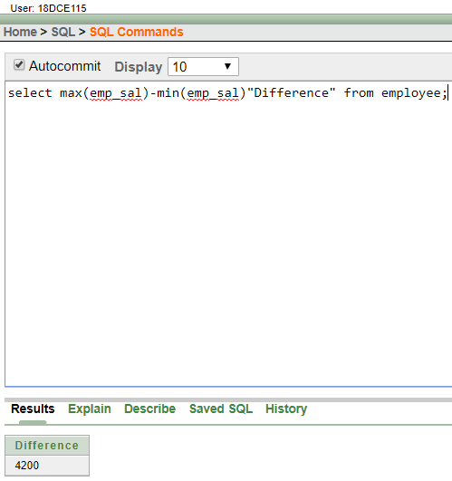

1. Create a query that will display the total number of employees and, of that total, the number of employees hired in 1995, 1996, 1997, and 1998.

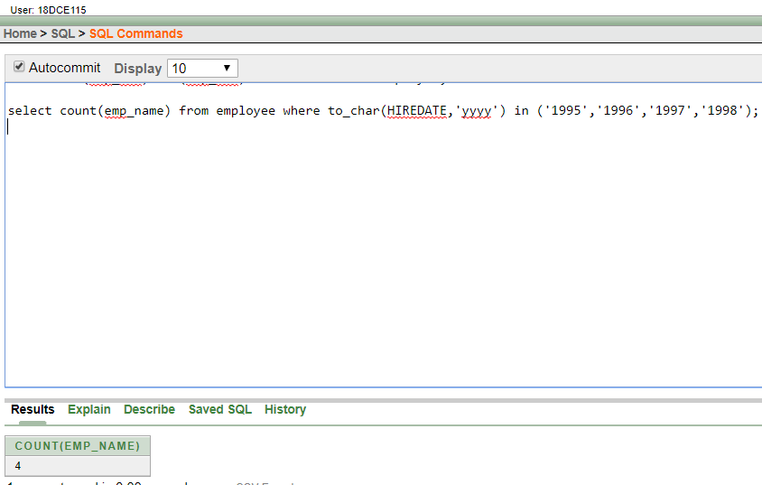

1. Find the average salaries for each department without displaying the respective department numbers.

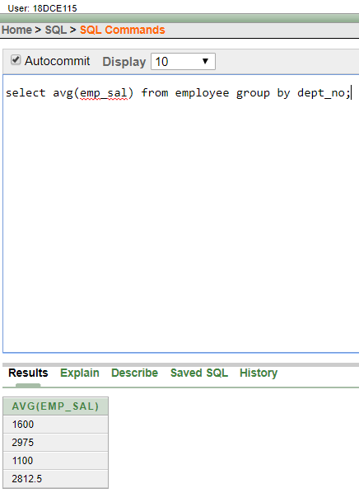

1. Write a query to display the total salary being paid to each job title, within each department.

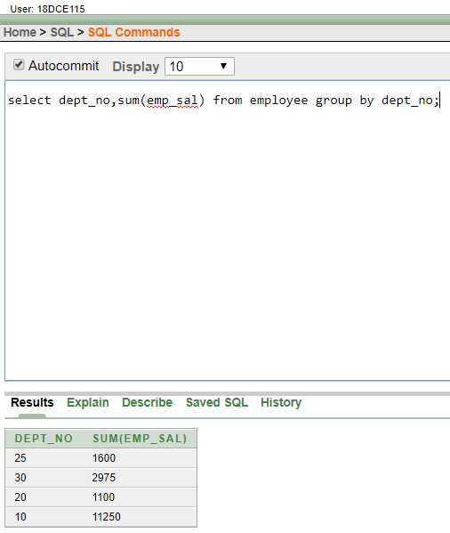

1. Find the average salaries > 2000 for each department without displaying the respective department numbers.

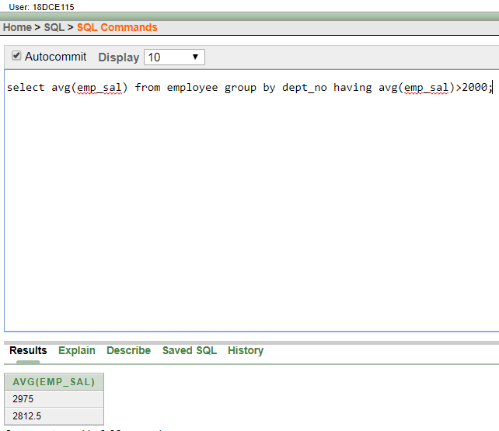

1. Display the job and total salary for each job with a total salary amount exceeding 3000, in which excludes president and sorts the list by the total salary.

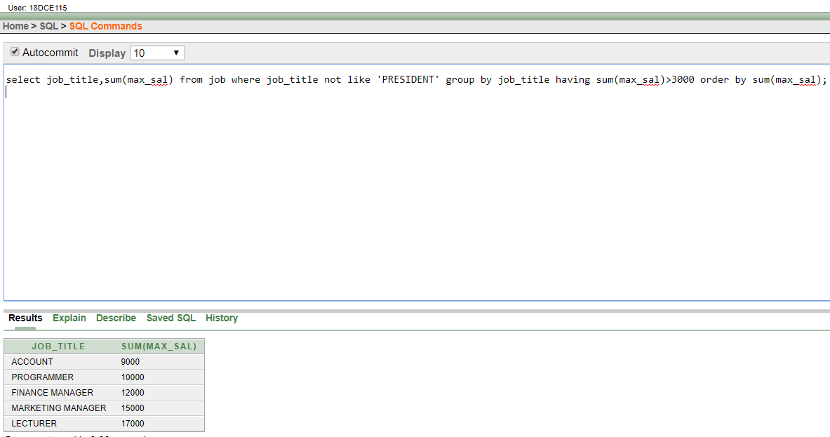

1. List the branches having sum of deposit more than 5000 and located in city bombay.

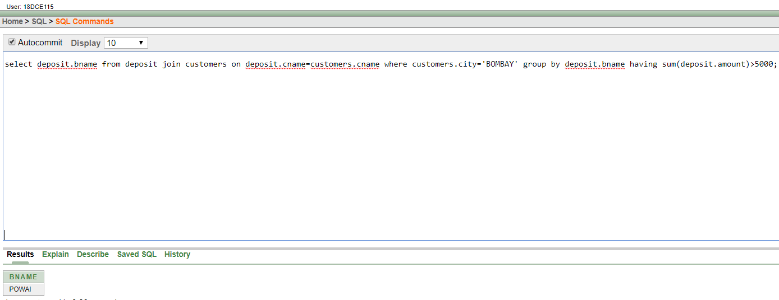

**Question/Answers**

Q.1) What is the use of aggregrating data using group function?

Ans. Aggregate functions perform a variety of actions such as counting all the rows in a table, averaging a column's data, and summing numeric data. Aggregates can also search a table to find the highest "MAX" or lowest "MIN" values in a column.

**CONCLUSION:**

In this practical we learned how to aggregate data using group function.

**PRACTICAL-8**

**Aim: To solve queries using the concept of sub query.**

**Hardware Required:** Computer/Laptop

**Software Required:** Oracle 10g Exe

**Knowledge Required:** Concept of sub query

**PROGRAM**:

1. Write a query to display the last name and hire date of any employee in the same department as SCOTT. Exclude SCOTT.

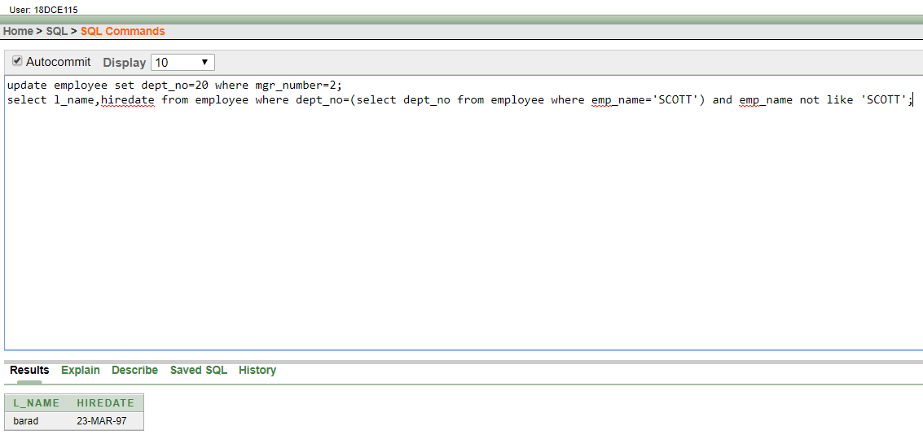

1. Give name of customers who are depositors having same branch city of mr. sunil.

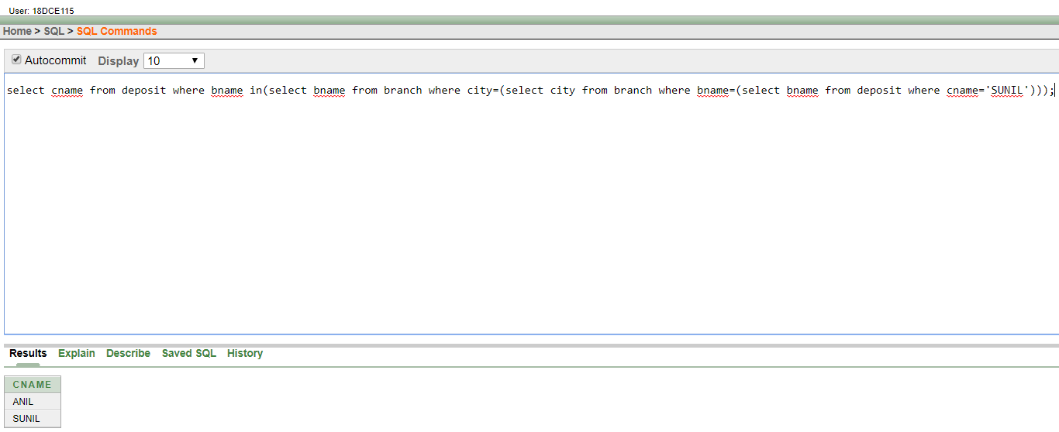

1. Give deposit details and loan details of customer in same city where pramod is living.

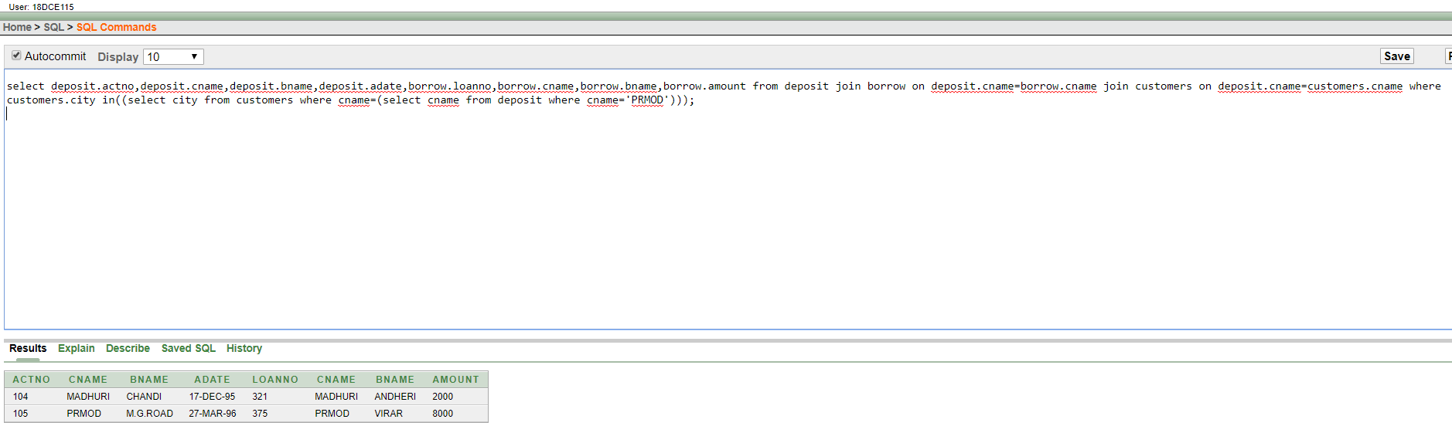

1. Create a query to display the employee numbers and last names of all employees who earn more than the average salary. Sort the results in ascending order of salary.

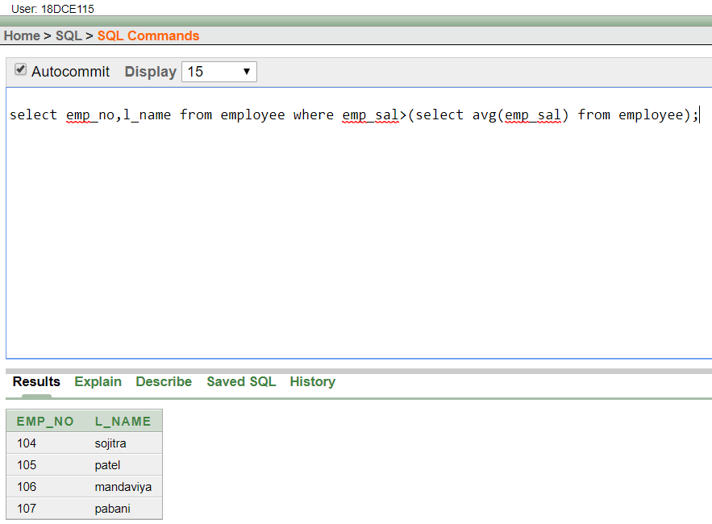

1. Give names of depositors having same living city as mr. anil and having deposit amount greater than 2000.

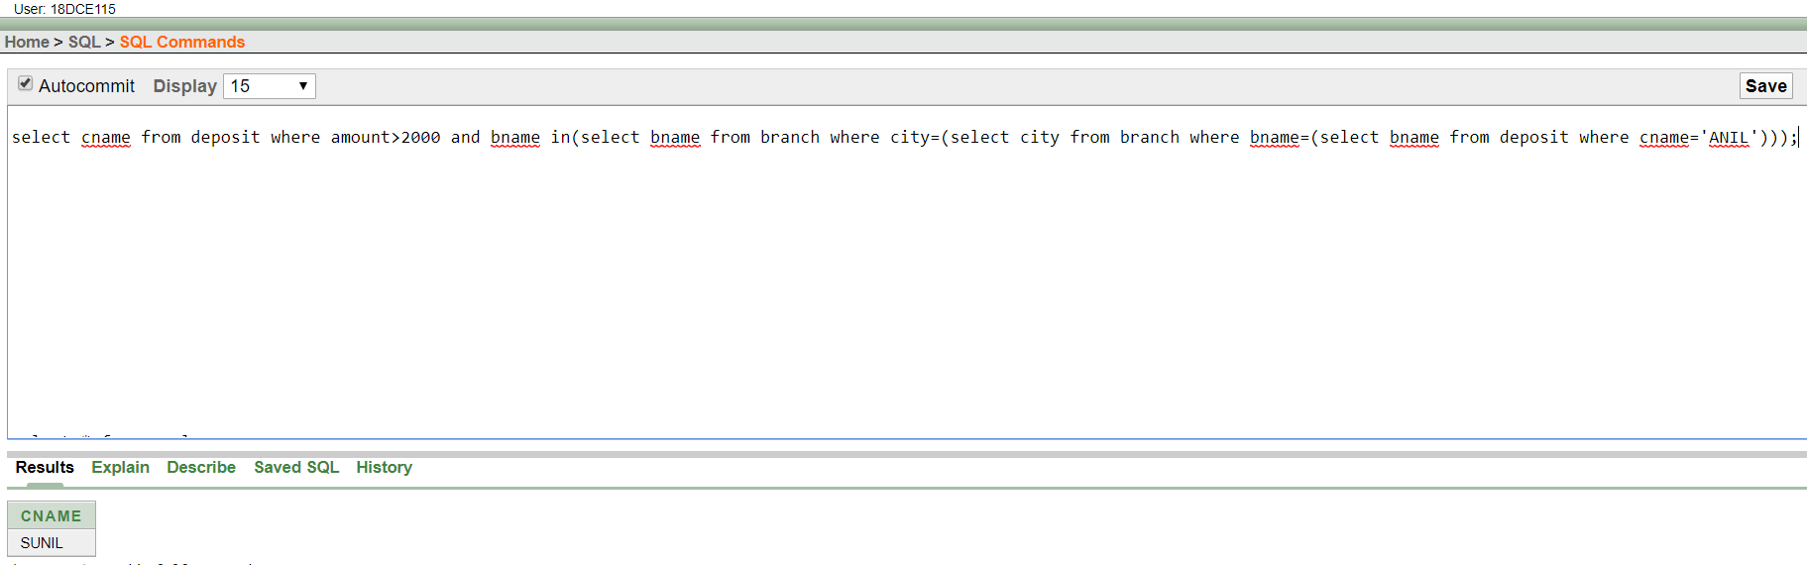

1. Display the last name and salary of every employee who reports to ford.

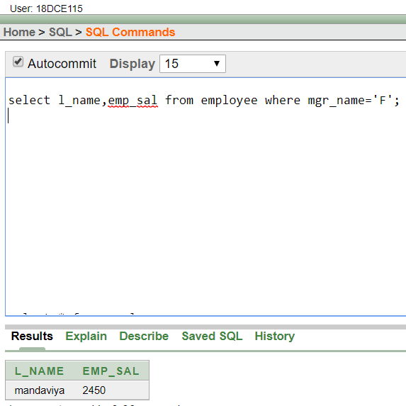

1. Display the department number, name, and job for every employee in the Accounting department.

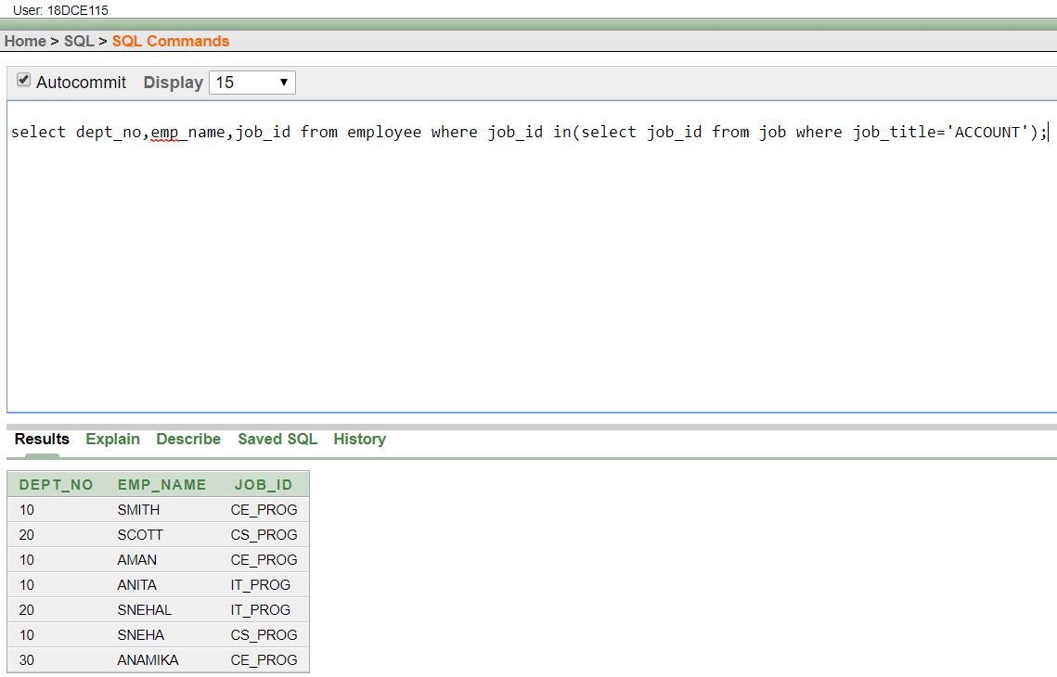

(8) List the name of branch having highest number of depositors.

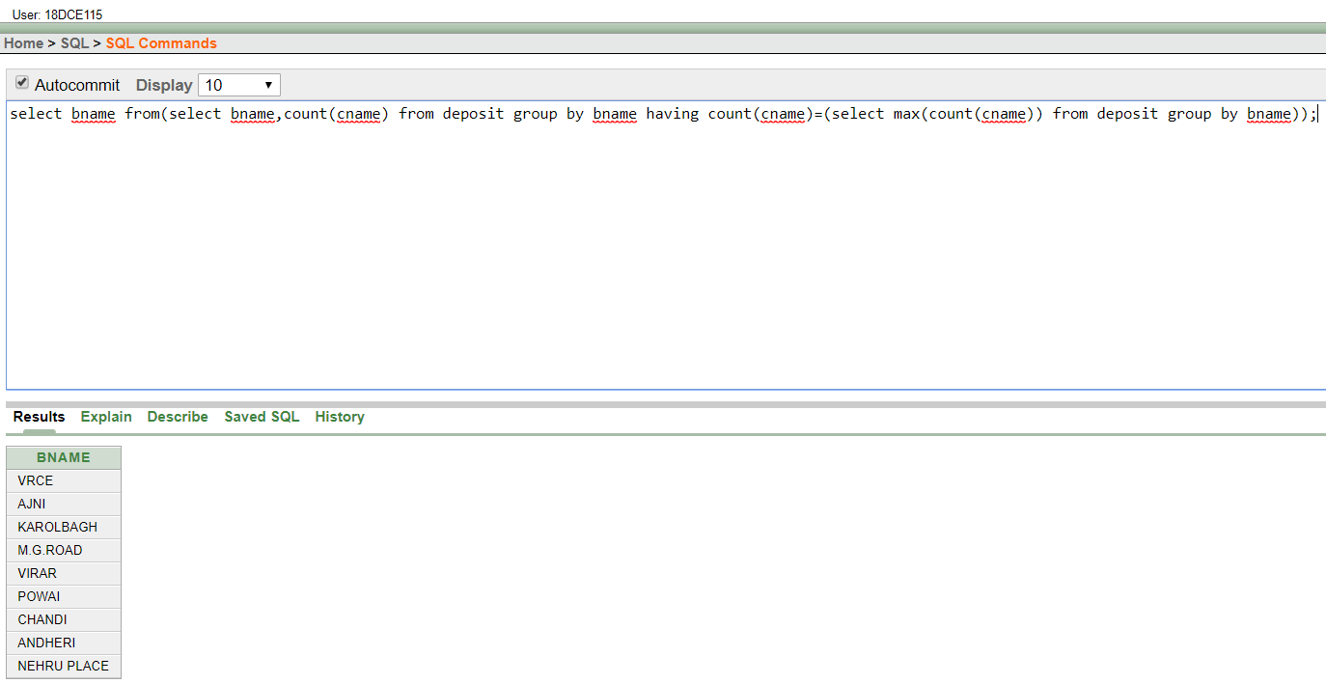

1. Give the name of cities where in which the maximum numbers of branches are located.

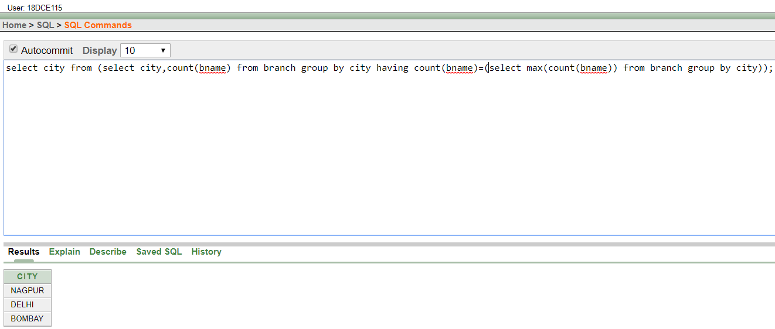

1. Give name of customers living in same city where maximum depositors are located.

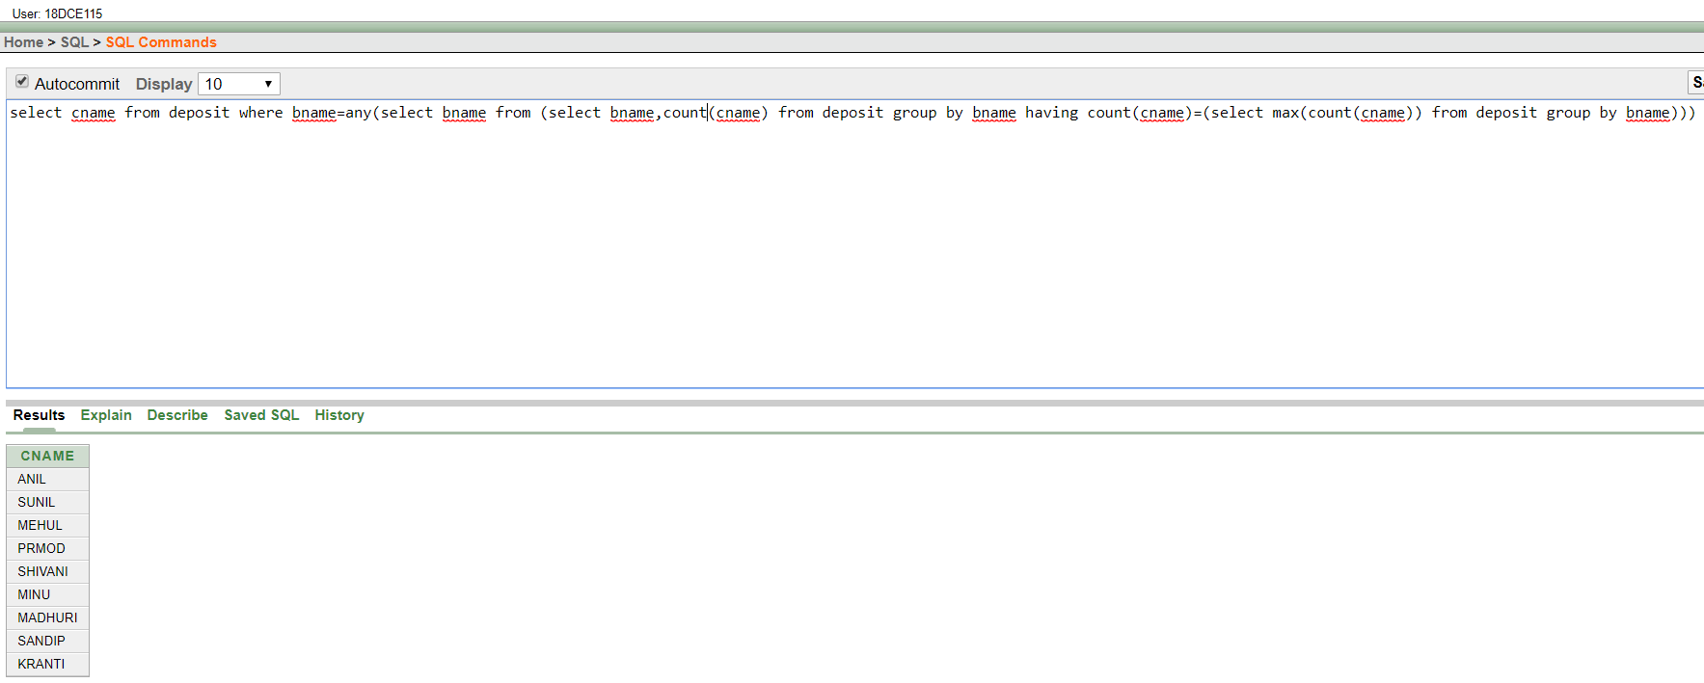

**Question/Answer**

Q.1) What is a sub query?

Ans. A Subquery or Inner query or a Nested query is a query within another SQL query and embedded within the WHERE clause. A subquery is used to return data that will be used in the main query as a condition to further restrict the data to be retrieved. ... A subquery cannot be immediately enclosed in a set function.

**CONCLUSION:**

In this practical we learned about the concept of sub queries.

**PRACTICAL-9**

**Aim: Manipulating Data**

**Hardware Required:** Computer/Laptop

**Software Required:** Oracle 10g Exe

**Knowledge Required:** Concept of manipulating data

**PROGRAM:**

(1) Give 10% interest to all depositors.

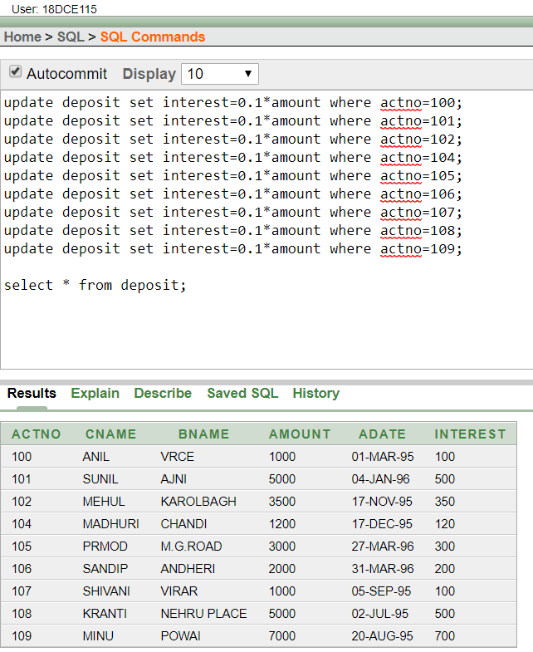

(2) Give 10% interest to all depositors having branch vrce

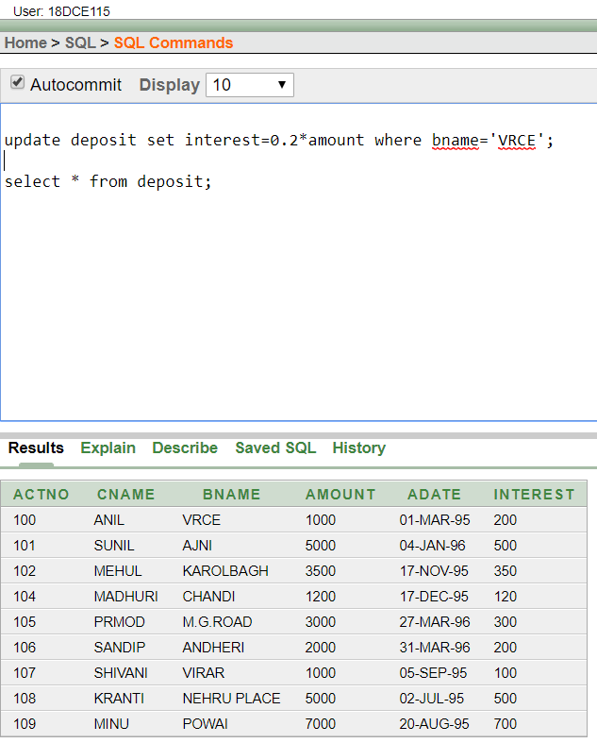

(3) Give 10% interest to all depositors living in nagpur and having branch city bombay.

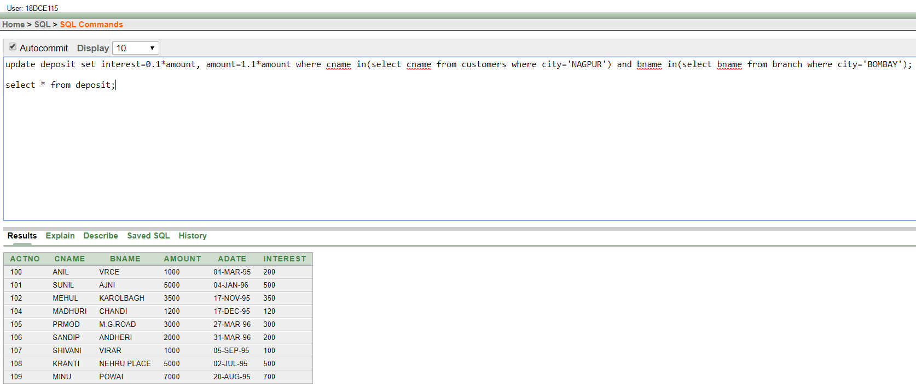

(4) Write a query which changes the department number of all employees with empno 7788’s job to employee 7844’current department number.

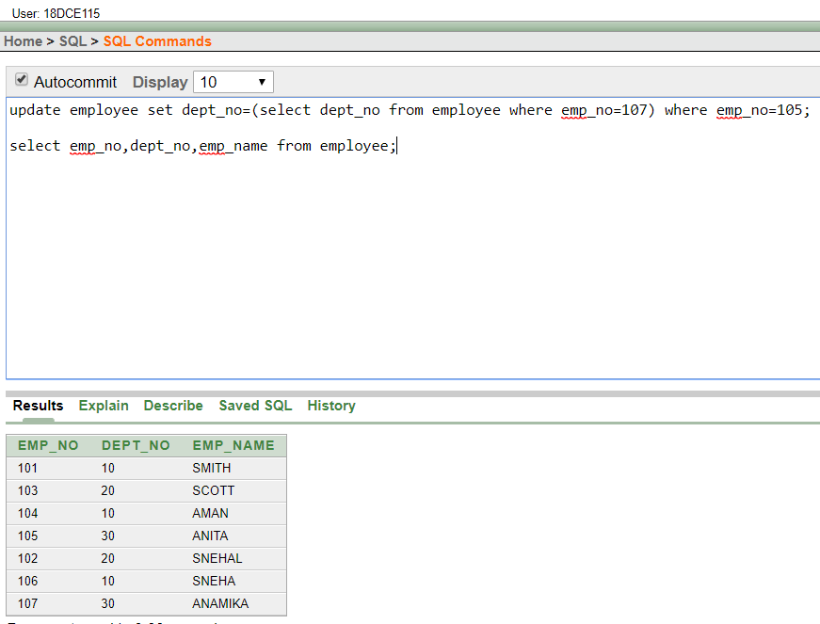

(5) Transfer 10 Rs from account of anil to sunil if both are having same branch.

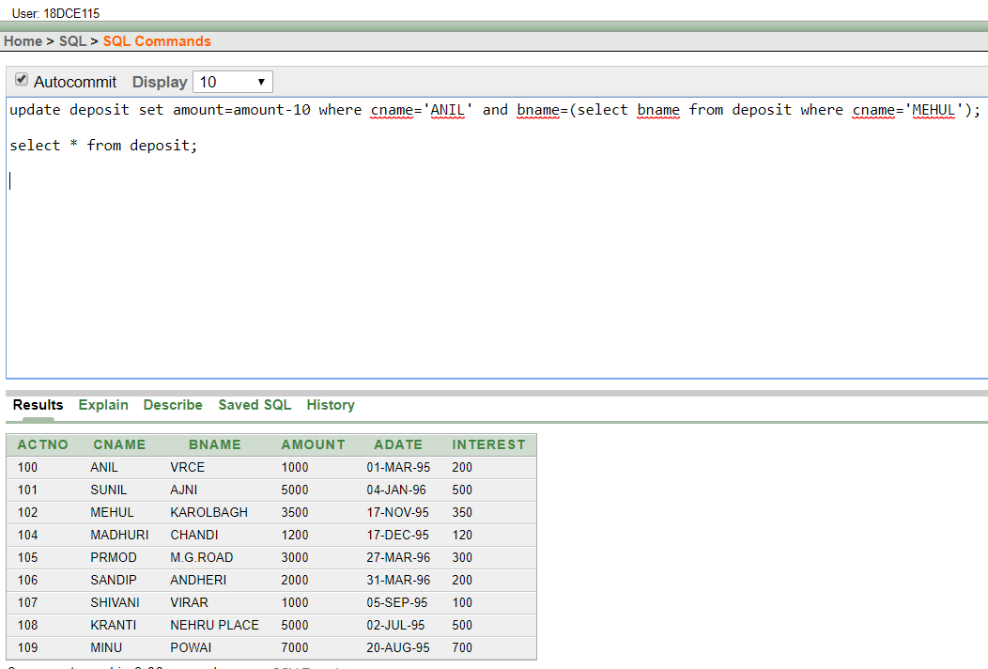

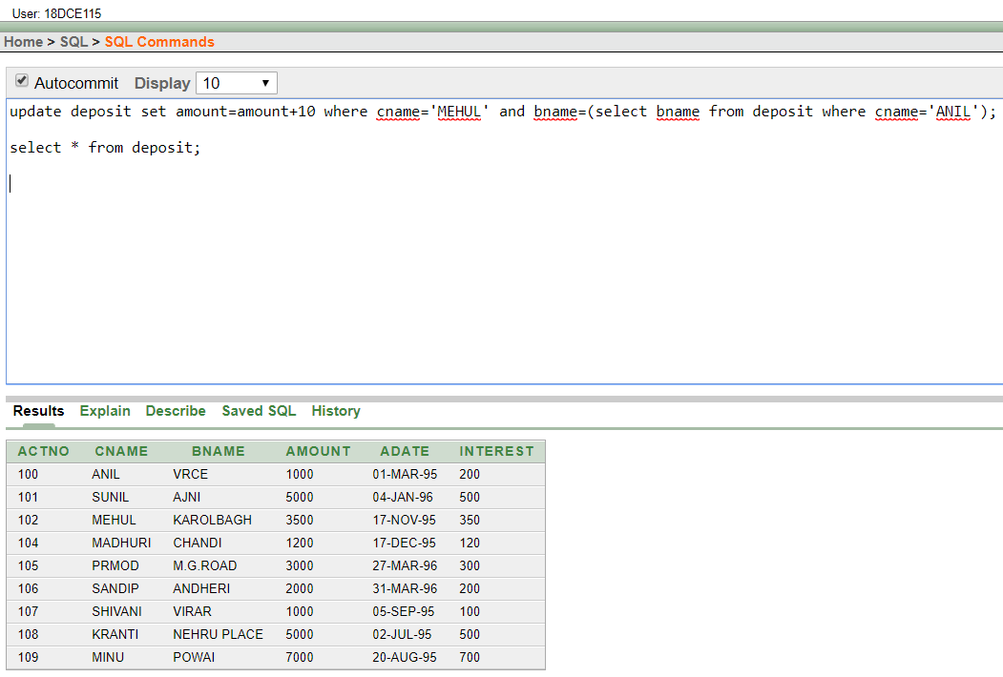

(6) Give 100 Rs more to all depositors if they are maximum depositors in their respective branch.

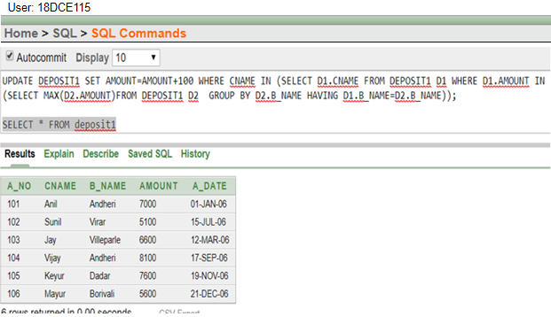

(7) Delete depositors of branches having number of customers between 1 to 3.

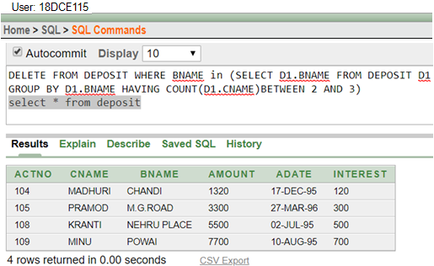

1. Delete deposit of vijay.

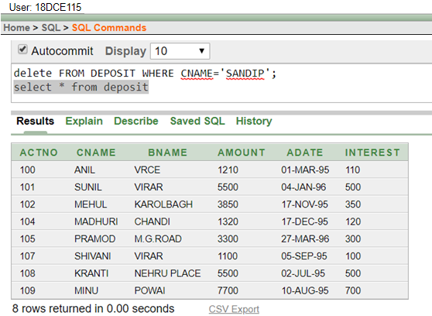

1. Delete borrower of branches having average loan less than 1000.

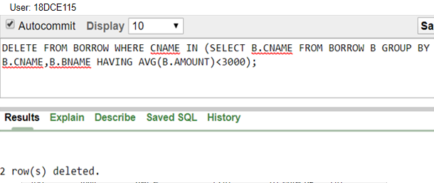

**Question/Answer**

Q.1) What is manipulating data in DBMS?

Ans. One of the primary functions of a database management system (DBMS) is to be able to manipulate data. This means adding new data, changing the values of existing data and reorganizing the data. Another basic form of data manipulation is to retrieve specific information from the database.

**CONCLUSION:**

In this practical we learned the concept of manipulating the data in DBMS.

**PRACTICAL-10**

**Aim: To perform basic PL/SQL blocks**

**Hardware Required:** Computer/Laptop

**Software Required:** Oracle 10g Exe

**Knowledge Required:** Concept of PL/SQL Block

**PROGRAM:**

Write a PL-SQL block for checking weather a given year is a Leap year or not.

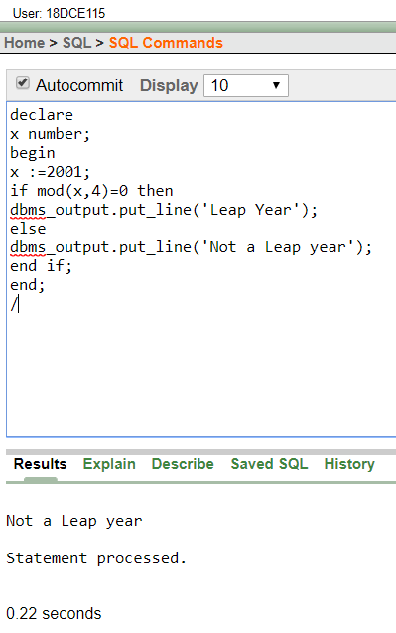

**CONCLUSION:**

In this practical we learnt basics of pl/sql block.

**PRACTICAL – 11**

**Aim: To perform the concept of loop.**

**Hardware Required:** Computer/Laptop

**Software Required:** Oracle 10g Exe

**Knowledge Required:** Concept of PL/SQL LOOP

**PROGRAM:**

Find out whether given string is palindrome or not using for, While and Simple Loop.

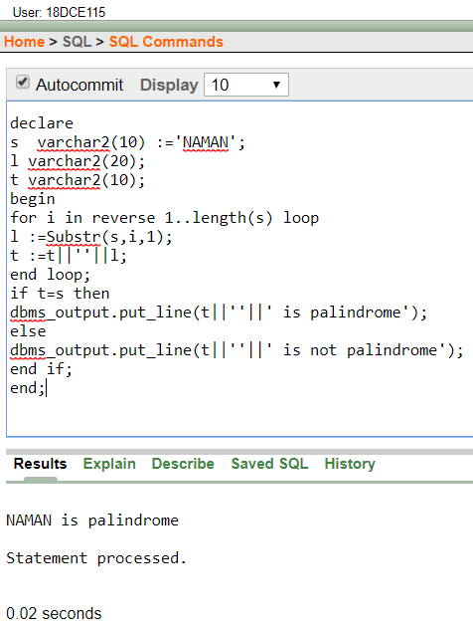

**CONCLUSION:**

In this practical we learned the concept of pl/sql loop.

**PRACTICAL – 12**

**Aim: To understand the concept of “select into” and “% type” attribute**.

**Hardware Required:** Computer/Laptop

**Software Required:** Oracle 10g Exe

**Knowledge Required:** Concept of PL/SQL block using (*) and duplication of table

**PROGRAM:**

Create an EMPLOYEES table that is a replica of the EMP table. Add a new column, STARS, of VARCHAR2 data type and length of 50 to the EMPLOYEES table for storing asterisk (*).

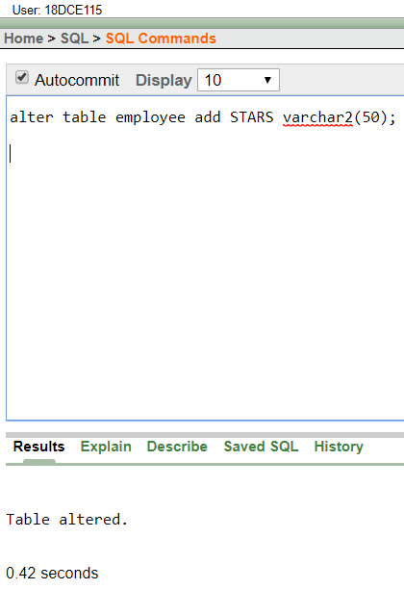

Create a PL/SQL block that rewards an employee by appending an asterisk in the STARS column for every Rs1000/- of the employee’s salary. For example, if the employee has a salary amount of Rs8000/-, the string of asterisks should contain eight asterisks. If the employee has a salary amount of Rs12500/-, the string of asterisks should contain 13 asterisks.

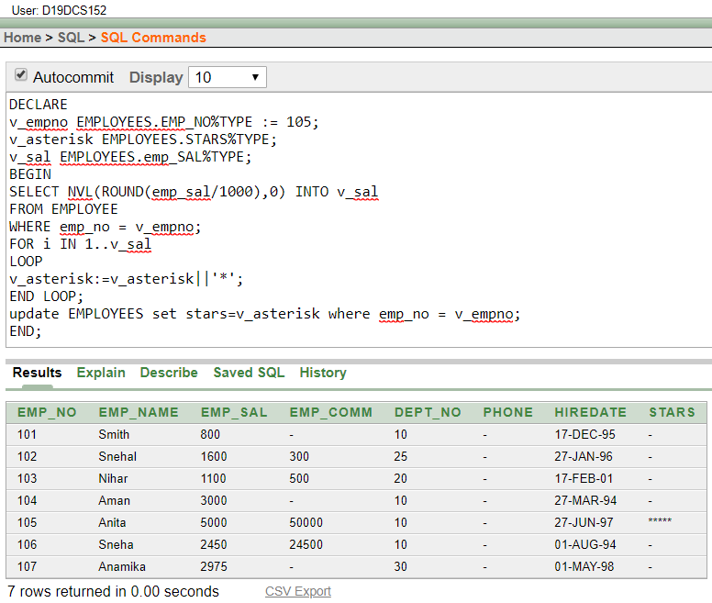Update the STARS column for the employee with the string of asterisks.



**CONCLUSION:**

In this practical we learned about pl/sql and how to create duplicate table with same values.

**PRACTICAL – 13**

**Aim: To perform the concept of cursor.**

**Hardware Required:** Computer/Laptop

**Software Required:** Oracle 10g Exe

**Knowledge Required:** Concept of PL\SQL %ROWTYPE and CURSOR

**PROGRAM:**

(a) Display all the information of EMP table using %ROWTYPE.

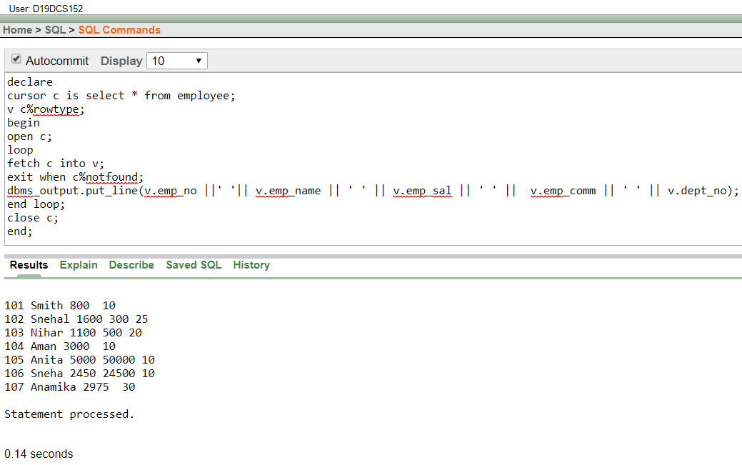

(b) Create a PL/SQL block that does the following:

In a PL/SQL block, retrieve the name, salary, and MANAGER ID of the employees working in the particular department. Take Department Id from user.

If the salary of the employee is less than 1000 and if the manager ID is either 7902 or 7839, display the message <<last name>> Due for a raise. Otherwise, display the message <<last_name>> Not due for a raise.

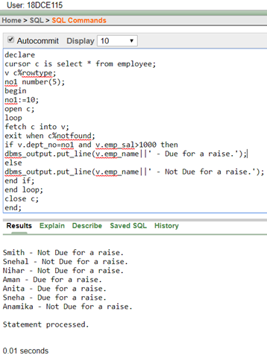

**CONCLUSION:**

In this practical we learnt about the concept of cursor in pl/sql.

**PRACTICAL – 14**

**Aim: To perform the concept of trigger.**

**Hardware Required:** Computer/Laptop

**Software Required:** Oracle 10g Exe

**Knowledge Required:** Concept of creating trigger

**PROGRAM:**

Write a PL/SQL block to update the salary where deptno is 10. Generate trigger that will store the original record in other table before updation take place

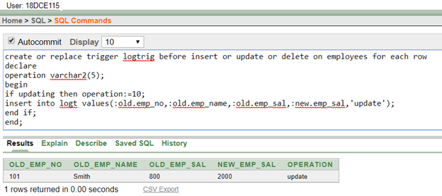

**CONCLUSION:**

In this practical we learnt about the concept of trigger in pl/sql block.

**PRACTICAL – 15**

**To perform the concept of function and procedure**

Write a PL/SQL block to update the salary of employee specified by empid. If record exist, then update the salary otherwise display appropriate message. Write a function as well as procedure for updating salary.

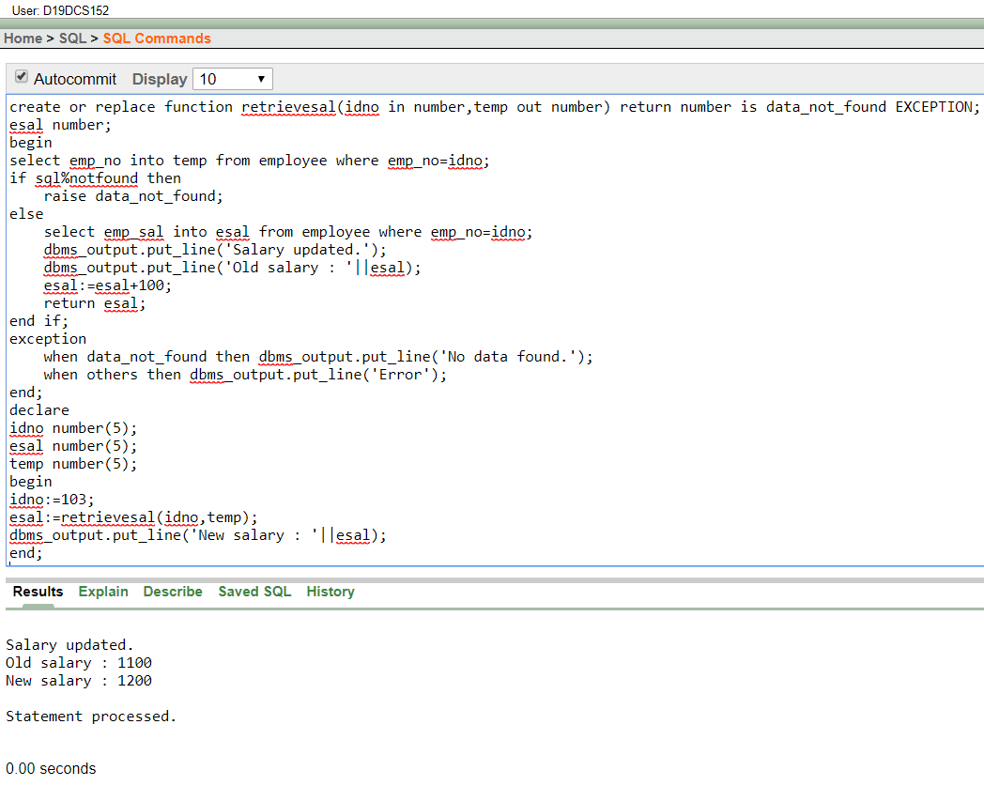**Using Function:**

**Using Procedure:**

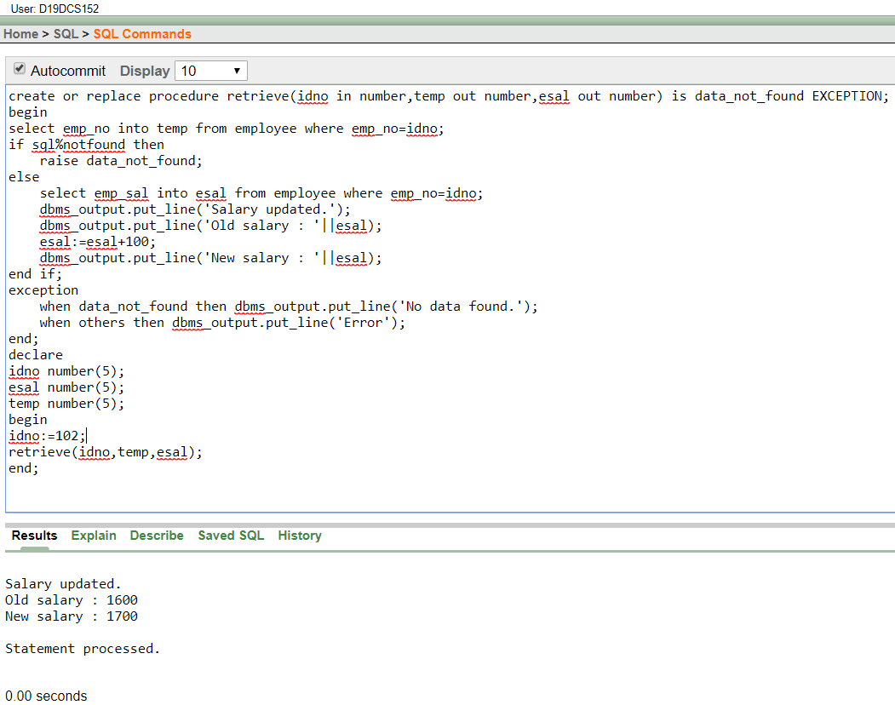

**CONCLUSION:**

In this practical we learnt about the concept of pl/sql functions.

**PRACTICAL – 16**

**Aim: To perform the concept of exception handler.**

**Hardware Required:** Computer/Laptop

**Software Required:** Oracle 10g Exe

**Knowledge Required:** Concept of PL/SQL Exception

**PROGRAM:**

Write a PL/SQL block that will accept the employee code, amount and operation. Based on specified operation amount is added or deducted from salary of said employee. Use user defined exception handler for handling the exception.

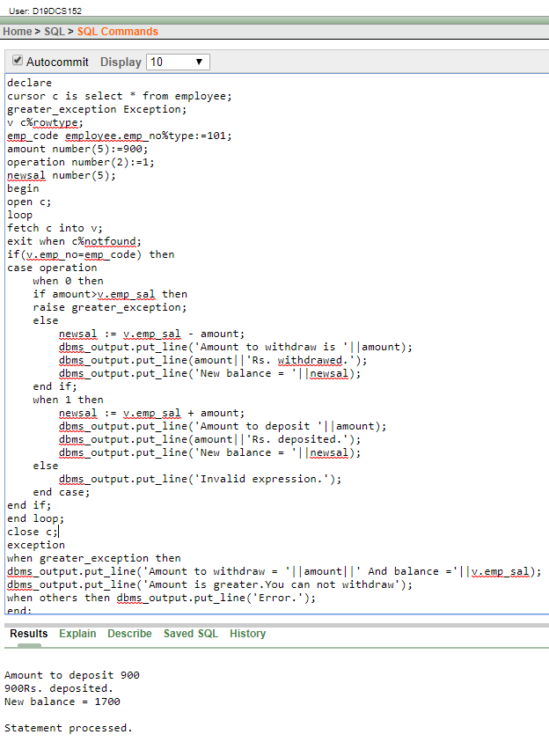

**CONCLUSION:**

In this practical we leant how to handle exception in pl/sql block.

**PRACTICAL – 17**

**Aim: To perform the concept of package.**

**Hardware Required:** Computer/Laptop

**Software Required:** Oracle 10g Exe

**Knowledge Required:** Concept of PL/SQL Package

**PROGRAM:**

Create and invoke a package that contains private and public constructs.

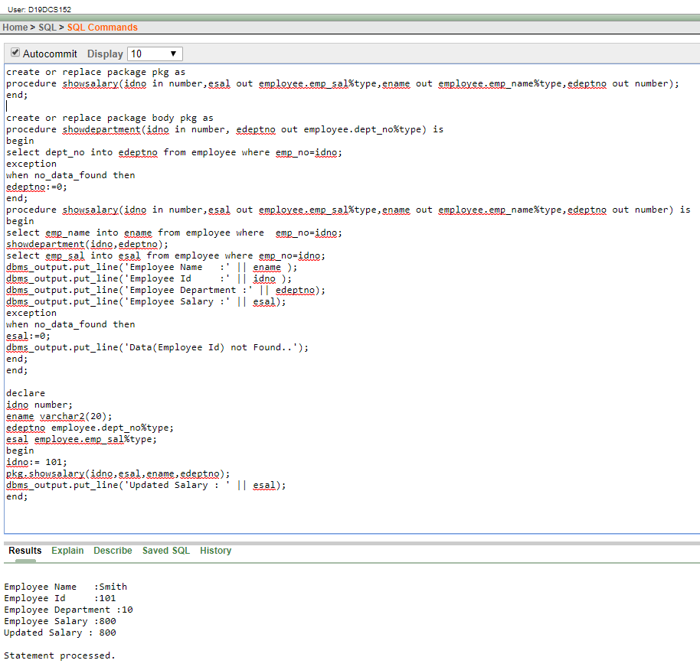

**CONCLUSION:**

In this practical we learned about the concepts of packages in pl/sql.

**QUESTIONS/ANSWERS (All topics of pl/sql block)**

Q.1) What is the use of pl/sql block?

Ans. In PL/SQL, All statements are classified into units that is called Blocks. PL/SQL blocks can include variables, SQL statements, loops, constants, conditional statements and exception handling. Blocks can also build a function or a procedure or a package.

Q.2) What is PL/SQL Loops?

Ans. The PL/SQL loops are used to repeat the execution of one or more statements for specified number of times. These are also known as iterative control statements.

Q.3) What is the concept of “select into” and “% type” attribute in PL/SQL?

Ans. PL/SQL SELECT INTO statement is the simplest and fastest way to fetch a single row from a table into [variables](https://www.oracletutorial.com/plsql-tutorial/plsql-variables/). The following illustrates the syntax of the PL/SQL SELECT INTO statement.

The %TYPE attribute, used in PL/SQL variable and parameter declarations, is supported by the data server. Use of this attribute ensures that type compatibility between table columns and PL/SQL variables is maintained. ... The data type of this column or variable is assigned to the variable being declared.

Q.4) What is the concept of cursor?

Ans. A cursor contains information on a select statement and the rows of data accessed by it. A cursor is used to referred to a program to fetch and process the rows returned by the SQL statement, one at a time. There are two types of cursors: Implicit Cursors. Explicit Cursors.

Q.5) What is the concept of function and procedure?

Ans. A function returns a value and a procedure just executes commands. The name function comes from math. It is used to calculate a value based on input. A procedure is a set of command which can be executed in order. In most programming languages, even functions can have a set of commands.

Q.6) What is the concept of exception handler?

Ans. Exception Handling in PL/SQL. An exception is an error which disrupts the normal flow of program instructions. PL/SQL provides us the exception block which raises the exception thus helping the programmer to find out the fault and resolve it. There are two types of exceptions defined in PL/SQL. User defined exception.

Q.7) What is the concept of trigger?

Ans.  In a DBMS, a trigger is a SQL procedure that initiates an action (i.e., fires an action) when an event (INSERT, DELETE or UPDATE) occurs. Since triggers are event-driven specialized procedures, they are stored in and managed by the DBMS. ... Each trigger is attached to a single, specified table in the database.

Q.8) What is a concept of package?

Ans. A package is a schema object that groups logically related PL/SQL types, variables, and subprograms. ... It declares the types, variables, constants, exceptions, cursors, and subprograms that can be referenced from outside the package. The body defines the queries for the cursors and the code for the subprograms.